WatchKnowLearn-Printable
http://www.watchknowlearn.org/default.aspx

- This is the home screen. The directory of videos is on the left and you can set the age range to find the appropriate videos for the students. The red tabs at the top provide more information.
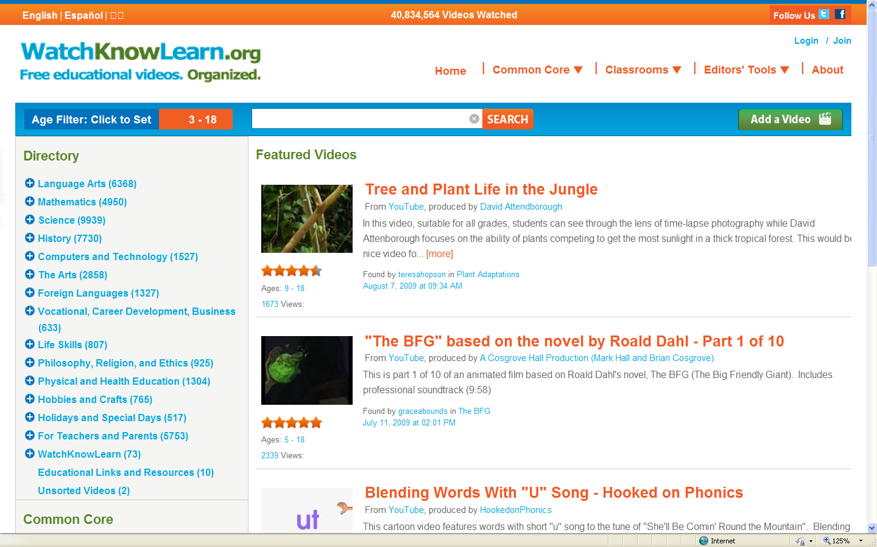

- Some examples under “Life Skills” (616 videos). Click on the blue + to open more options under a topic. To watch the selected video click on the red title.
