Sen Teacher Website-Printable
http://www.senteacher.org/
- This is the home screen.
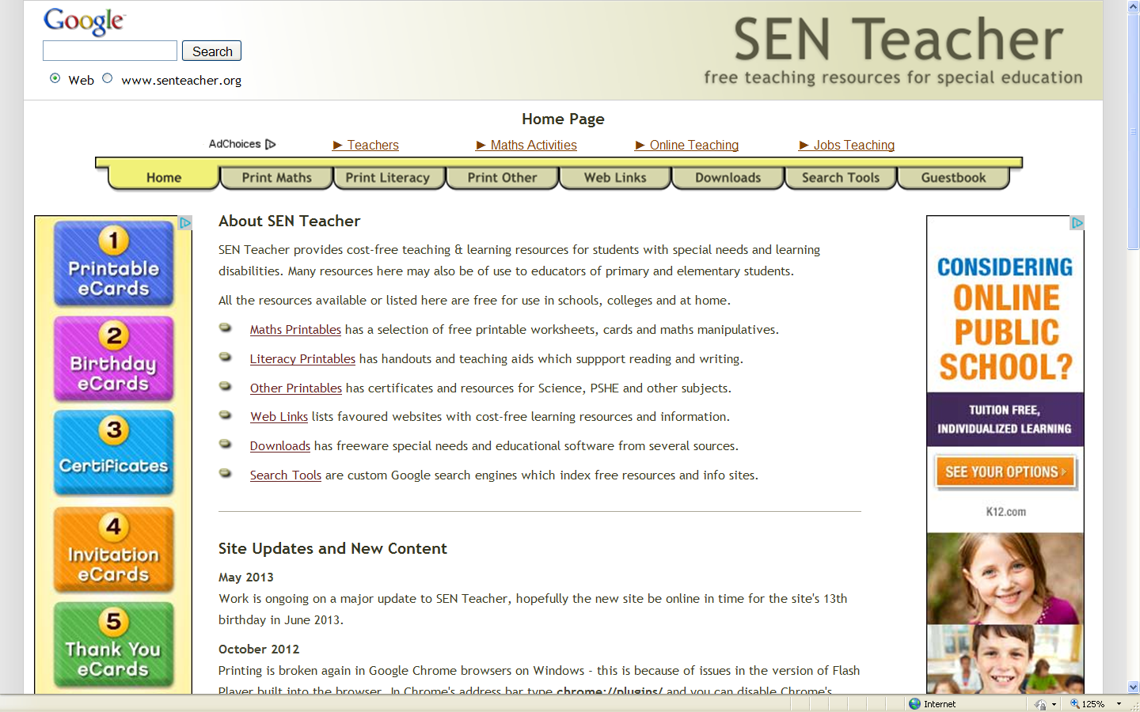

- At the tabs at the top click on “Downloads” to view/download resources.
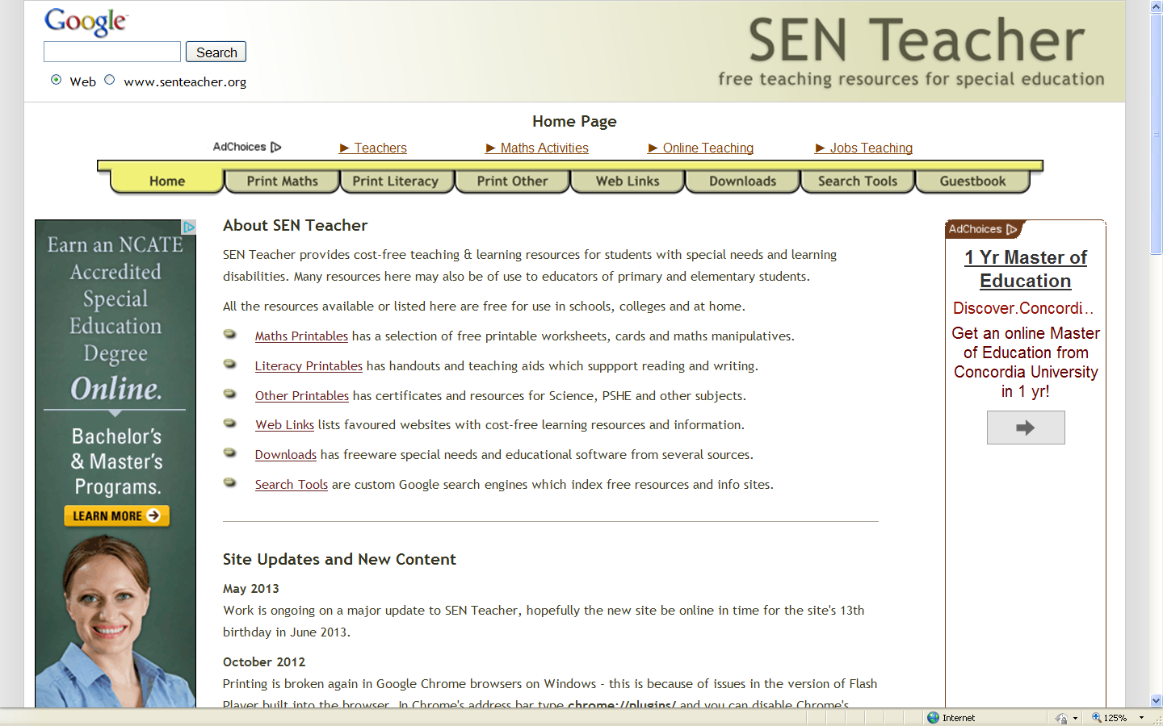

- You will see downloads available for mathematics, communication, using computers and the arts to name a few. Click on and follow the on-line instructions to download.
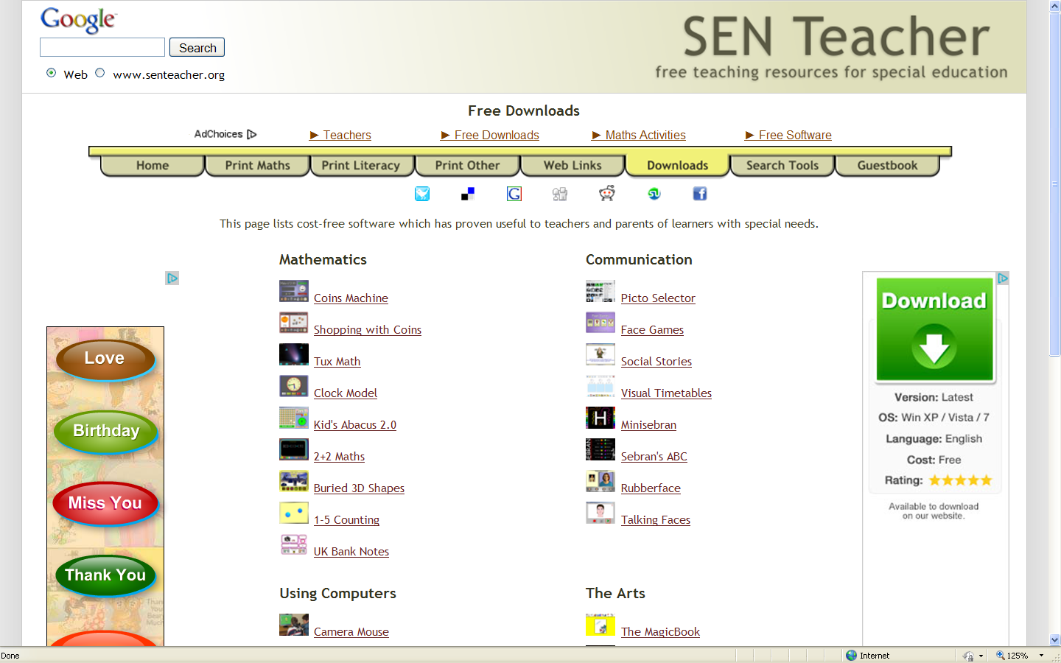

- Now, click on “Search Tools” (note: a new window will open). You can search by disability area which will narrow your search parameters.
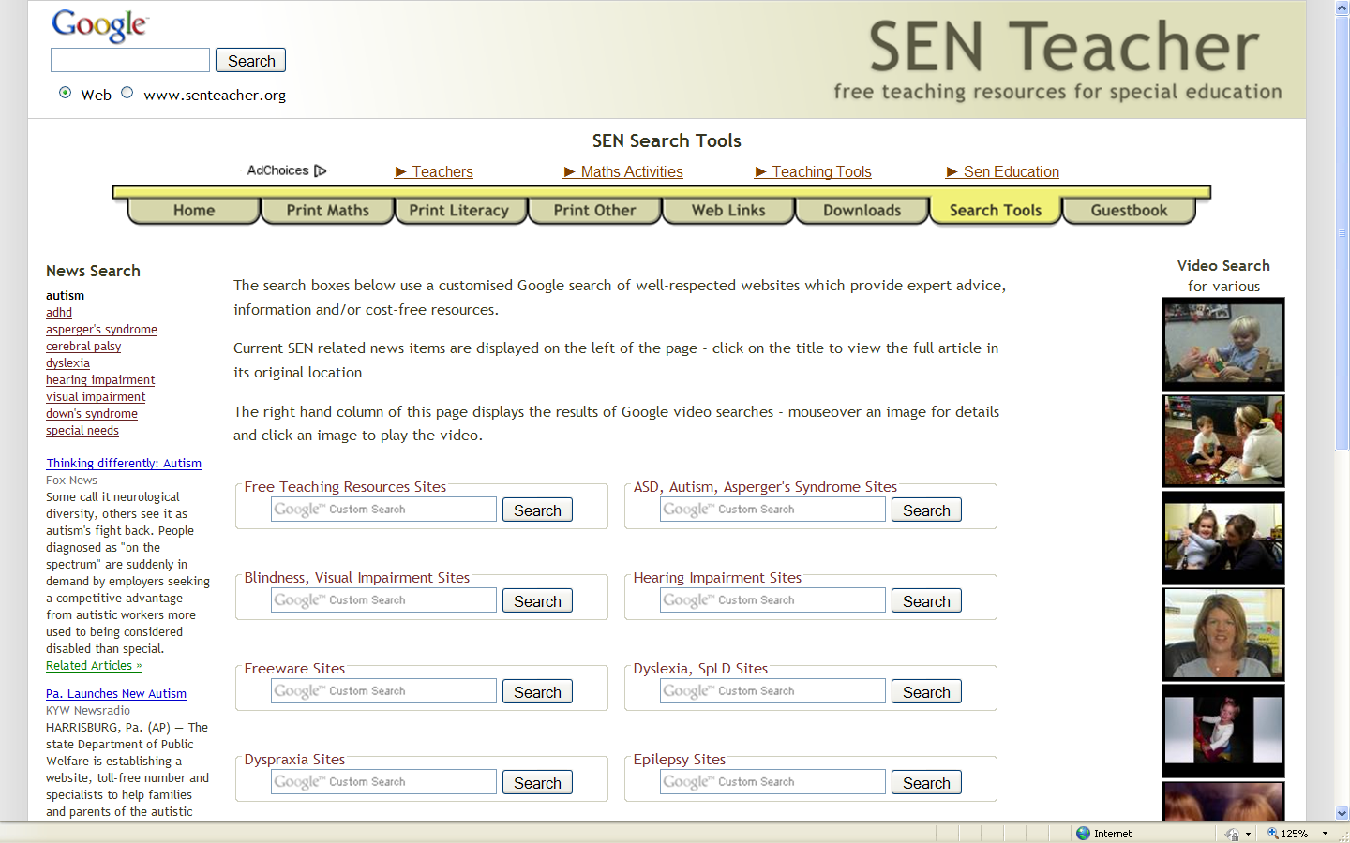

- Now, click on “Print Literacy”. You will find many worksheet, templates, etc. to choose from. You will also find similar items under “Print Math” and “Print Other”
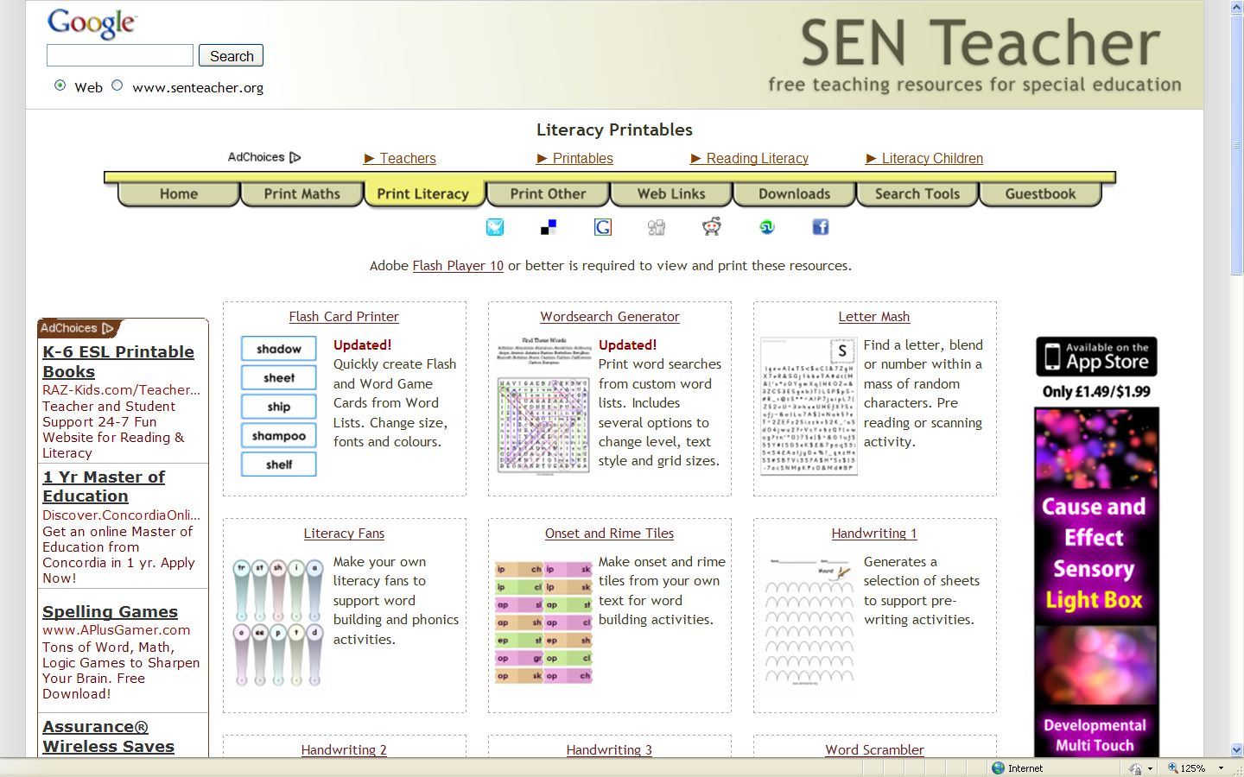

- Click on “Web Links” and you will find links that are by condition, free resources and other helpful sites.
