Autism Resource Center Website-Printable
http://www.gvsu.edu/autismcenter/
- This website has many resources, but we are starting with “Secondary Transition to Adulthood”
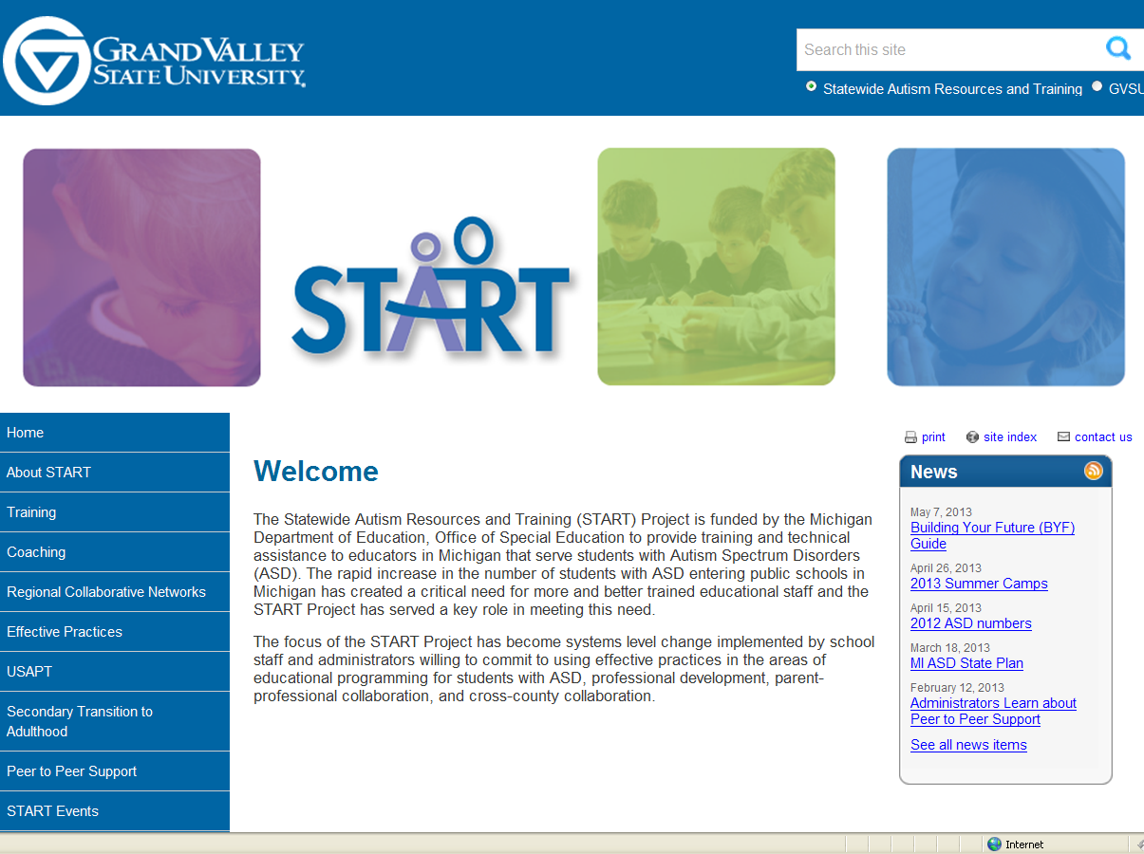

- When you click on “Secondary Transition to Adulthood” you will be taken to this screen where you can choose “Transition Resources” or “START BYF Project”.
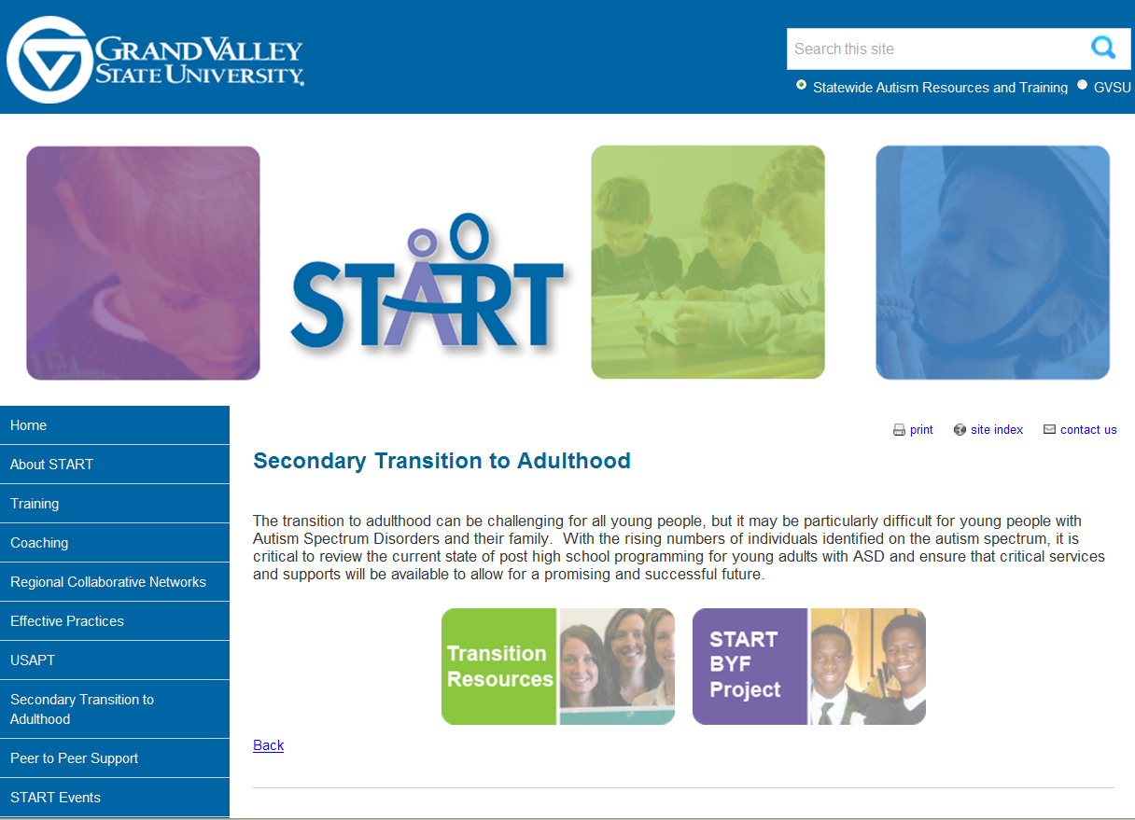

- If you click on “START BYF Project” you will be taken to this screen.
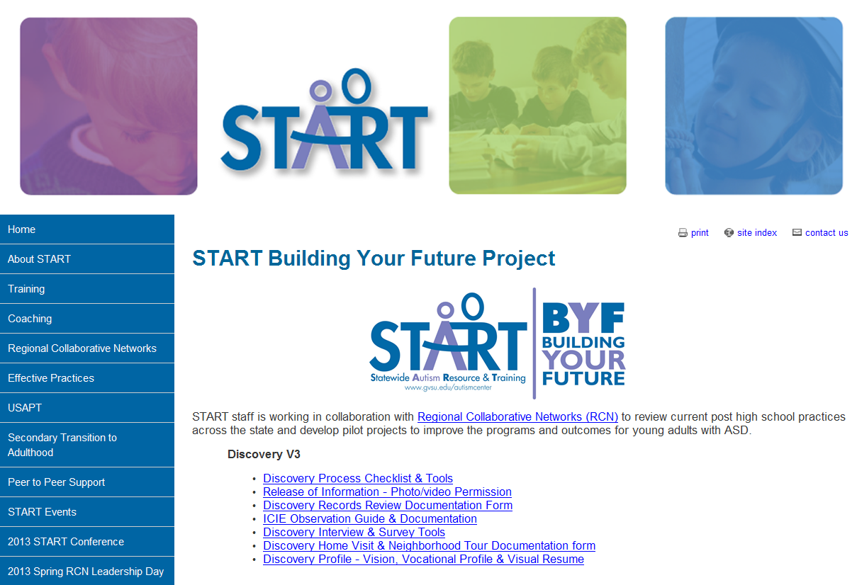

- If you click on “Transition Resources” you will be taken to this screen. Where you can go to “Accommodations”, “Transition Planning” and more
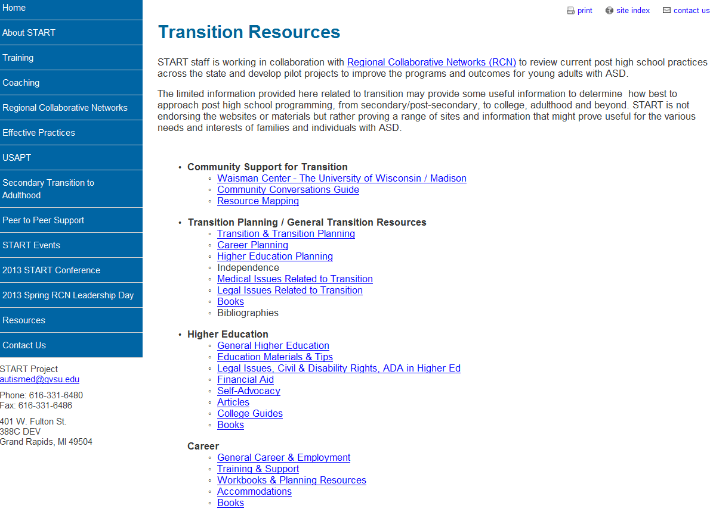

- This is what is on the “Accommodations” page.
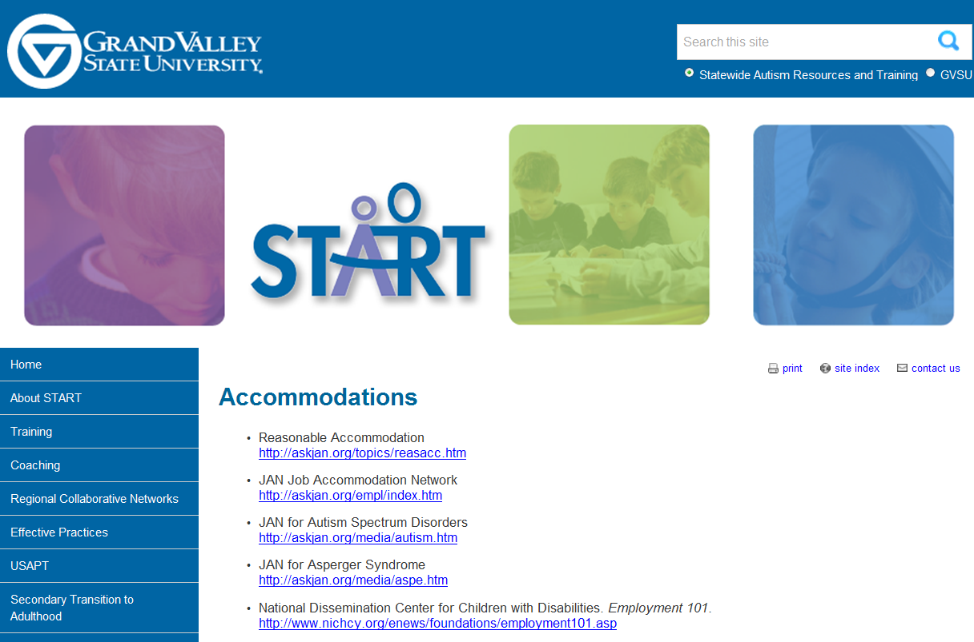

- And the “Transition Planning” page.
