O’NET Resource Center Website-Printable
http://www.onetcenter.org/
- O’NET has many career oriented resources for teachers, students and job seekers. The home page looks like this. Click on “My Next Move”
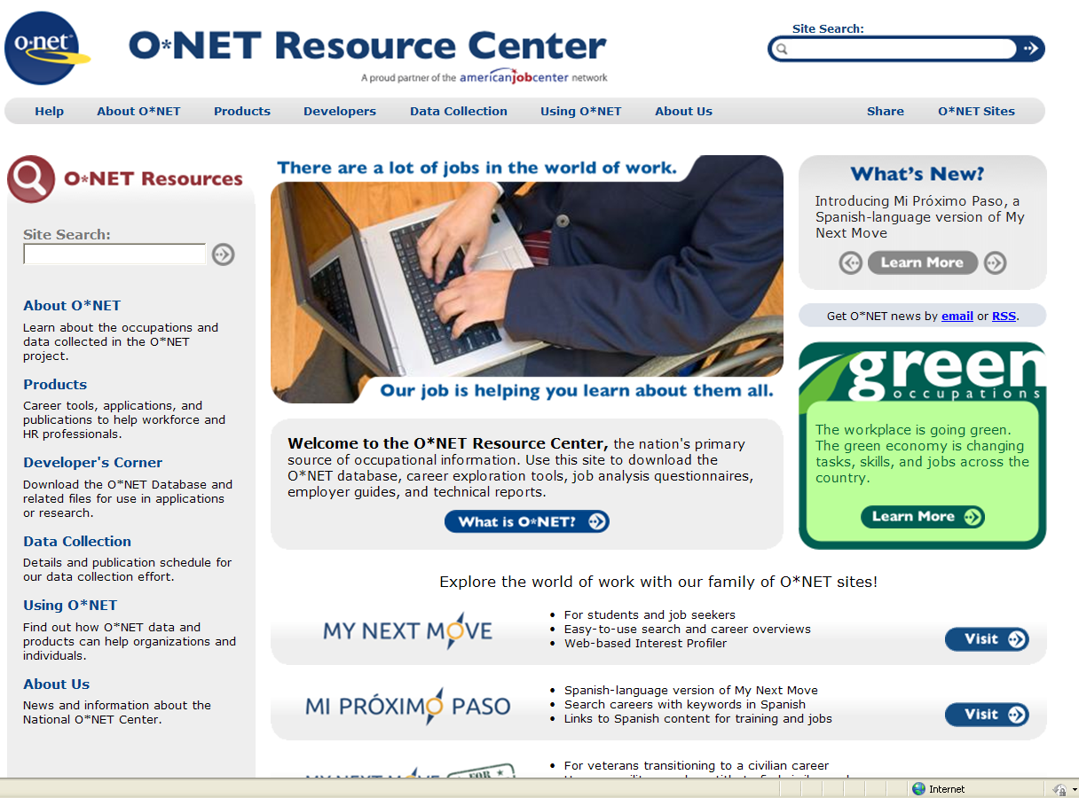

- This page concentrates on “What do you want to do for a living?”
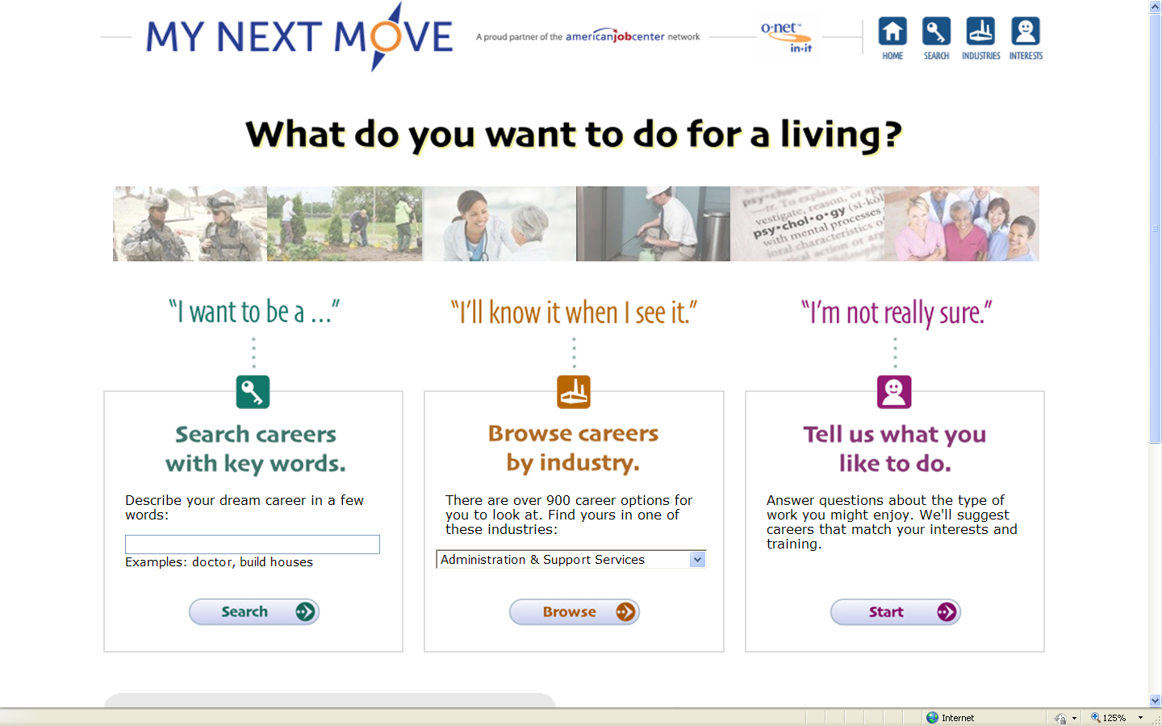

- Now, if you want to go to “O’NET Academy” go back to the home page and click on “O’NET Sites.
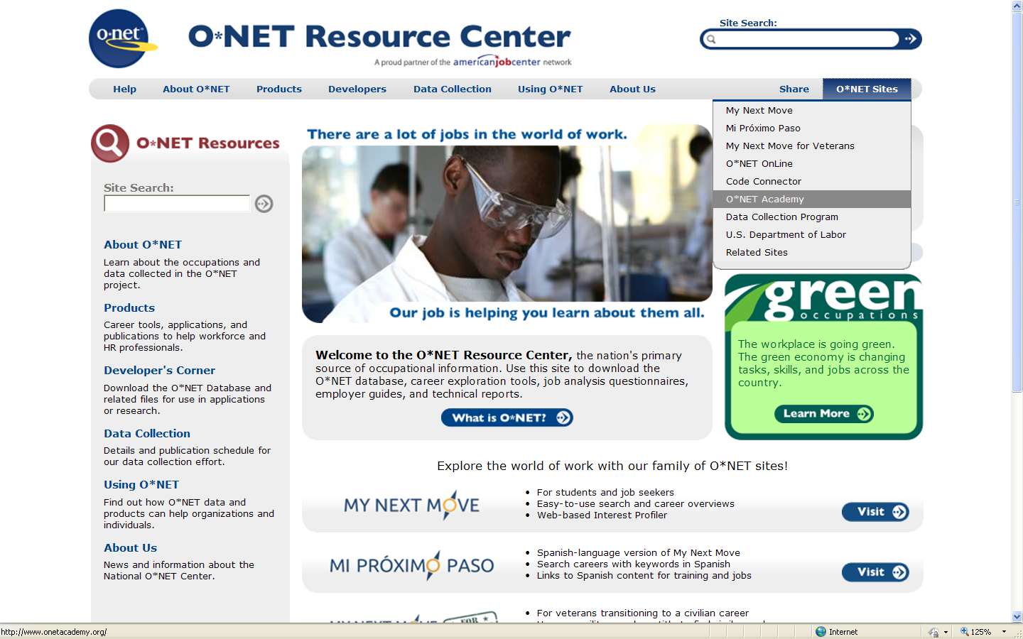

- At the top you will see headings for workforce professionals, employers, educators and job seekers as well as podcasts, webinars, courses, etc.
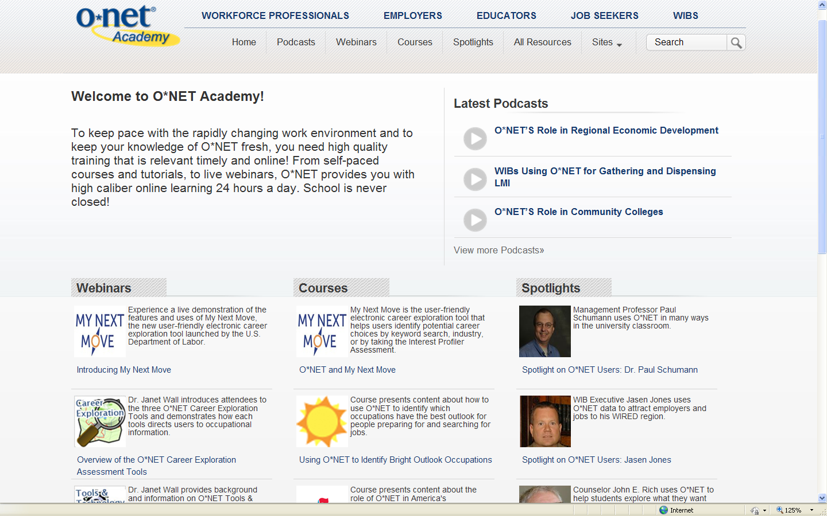

- If you click on “Educators” you will be taken to this page where you will find many resources.
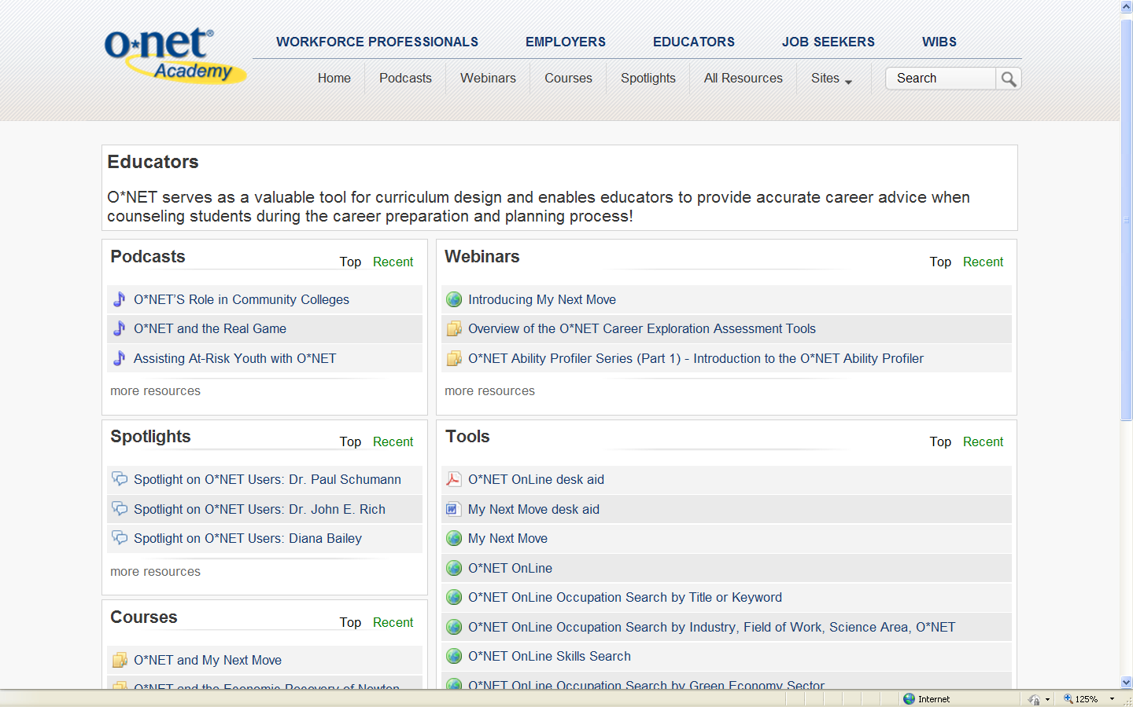

- If you click on “Job Seekers” you will be taken to this page where you will find more resources.
