Job Tips Website-Printable
www.do2learn.com
- Use the above link to access the Do2Learn website. This is what the site looks like. There is a “basket” on the upper right, but the site has free materials as well as items to purchase. You can hover over of any tabs at the top or “Tip” along the side and a drop down menu will appear.
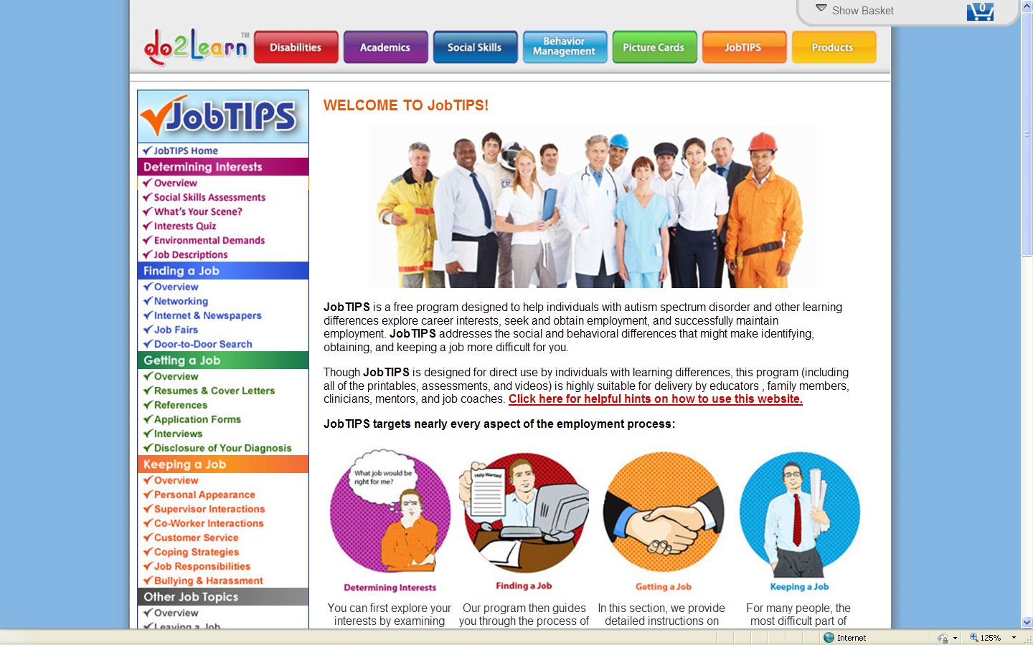

- Hover over the orange “JobTips” and a drop down menu appears. This is what you will find under this tab.

- Hover over the “Social Skills Assessments” and new menu appears. Click on “Assessments”.

- The “Assessment” page will open and click on “Print out this self-assessment” (Note: the assessment does not open into another window) 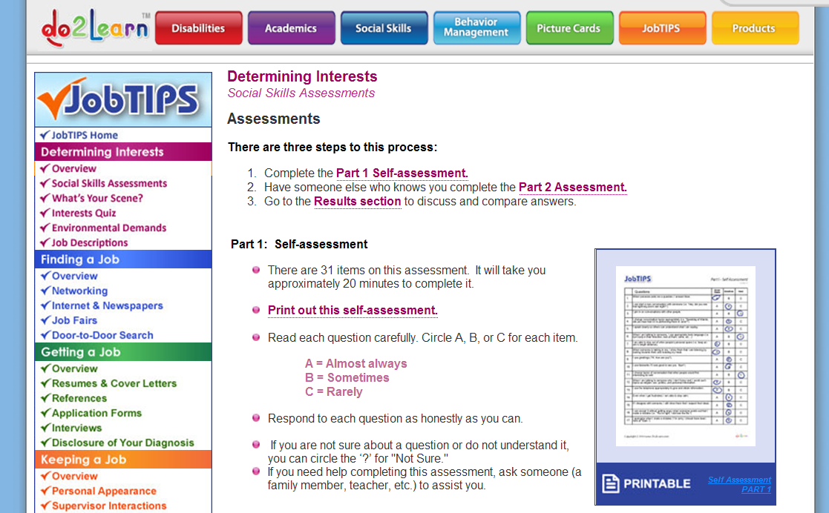

- Other job skills such as finding a job, getting and keeping a job are found on the left side of the page.

- Under the “Social Skills” tab you will find “Social Skill s Toolbox”

- You will see this page. Free materials/information is in the panel to the left.

- Information found under the other tabs at the top of the page-Disability

- Academics

- Behavior Management

- Picture Cards

