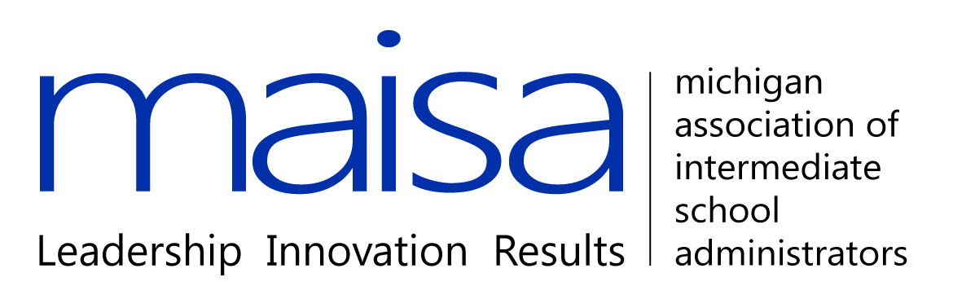

MAISA GELN Common Core and Assessment Opt Out
Talking Points

General Common Core Statements:

- The Michigan Standards were approved by the State Board of Education 3 years ago in 2010.

- The Michigan Legislature has given final approval for funding the implementation of the common core on November 1, 2013.

- The Common Core Standards adopted by 45 states demand critical thinking and problem solving.

- Michigan has not committed to a specific assessment yet, but the legislative resolution asks that assessments be given on computers, provide real time results and be taken twice a year (Michigan Legislature Resolution).

Initial draft email information shared with us from Brad Biladeau’s office via Rachel Dickman.

Hi Karen,

I hope all is well! I had an opportunity to talk with Brad about the CCSS & SBAC opt out option. We are reaching out to MDE to get verification and direction. However, upon initial review, here are our observations:

From what we can tell, Michigan law makes it incredibly difficult (if not impossible) for the parents to opt out of CCSS and SBAC. It seems like the main reason why a student cannot opt out is because this curriculum & test will be required to receive a high school diploma from a Michigan high school. Sec. 1278a of The Revised School Code prohibits a Board of Education to award a high school diploma to any pupil who does not complete the credit requirements that are aligned with subject area content expectations developed by MDE & approved by the state board (i.e., CCSS).

Moreover, a district must base its determination of whether a pupil has successfully completed the subject area content expectations developed by MDE (CCSS) at least in part on the pupil’s performance on the assessments developed or selected by MDE or on 1 or more assessment developed or selected by the school district that measure a pupil’s understanding of the subject area content expectations. So, unless the school district in which the student is located has another locally developed assessment of the standards selected by MDE (CCSS), the student would have to take the assessment; or, if they opted out, they would have to essentially “hope” that the district only uses the state assessment as a very small portion of determining their successful completion of the subject area.

Finally, Sec 1278a also states that a school board may require a pupil to complete the Michigan Merit Exam or require a pupil to participate in the MIAccess Assessments, if appropriate. Now, we don’t know what the legislature plans on doing with the Michigan Merit Exam section of code (1279g), but if they simply replace the Michigan Merit Exam with a grade 11 SBAC exam, this could mean that a student couldn’t opt out of the exam if they wanted to receive a high school diploma and their local school board required the student to at least complete the exam.

I hope this helps a bit for now but again, we are waiting to get verification from MDE and we will send you additional clarification once we receive it from MDE. Please feel free to call or e-mail me if you have any comments or would like to discuss anything further.

All the best,
Rachel

Additional email:
Brad actually just got off the phone with MDE and they said that they are in the process of developing a response around how to respond to parents who choose to opt out of Common Core & SBAC. MASA will be working with them to help coordinate & draft that response. Based on our preliminary research, we believe the statutes listed in the previous e-mail have oversight over these issues. However, as I mentioned before, we are continuing to work with MDE and get further clarification on this and will keep you informed as to their response.

