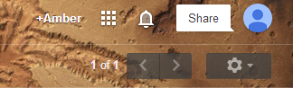

Select the squares. This is found in the upper right of your email page.

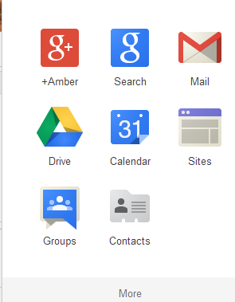

Select DRIVE

For all of your documents, they are in MY DRIVE. If they were shared with you, they would be in the SHARED WITH ME drive.