Schools of Choice Data- Where are kids coming from/going to?
Go to www.mischooldata.org
Select Student Counts:
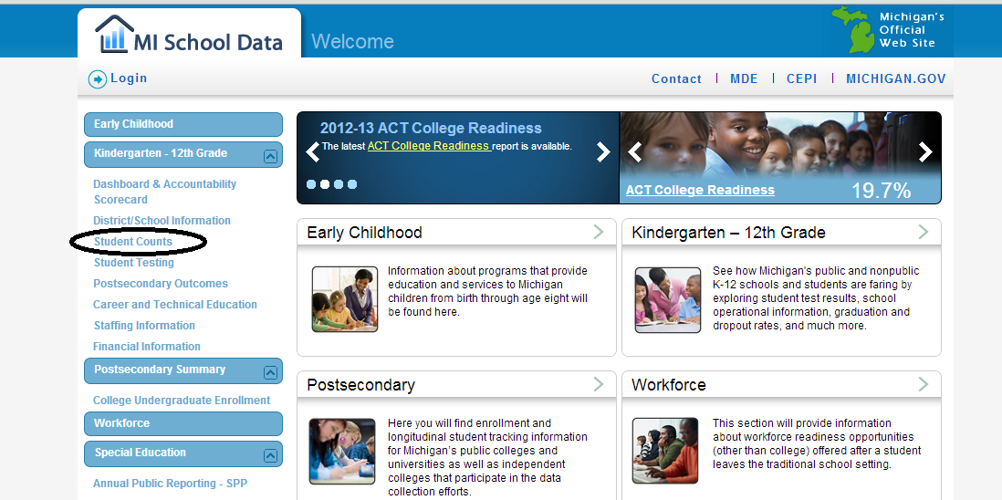
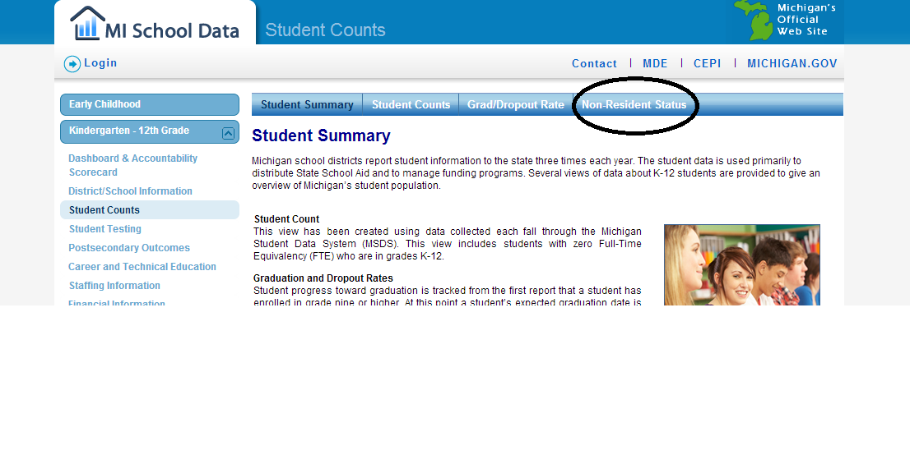
Select Non-Resident Status:

- Select Clare- Gladwin RESD
- Select Your School
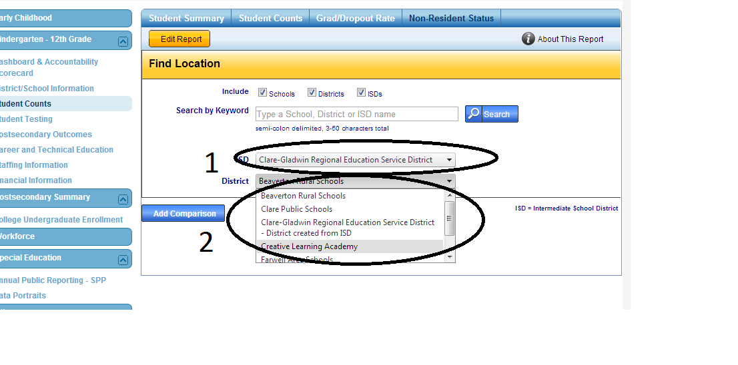

Select a School Year, Grade (or all Grades), and Residency Status:
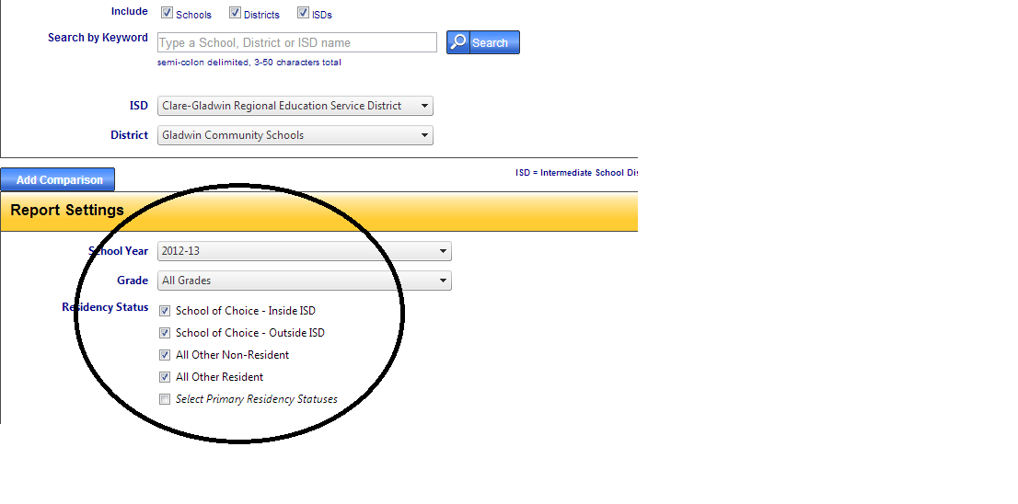
Click to view results:
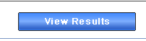
A longer blue bar represents a net loss of students to that district.

A longer green bar represents a net gain of students to that district.

Questions? Call Joe Trommater, CGRESD Data Coordinator 989-386-8602

