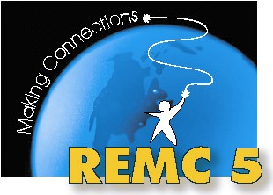
REMC 5 Advisory
November 1, 2013
Gratiot-Isabella RESD - Ithaca
AGENDA

Morning – Professional Learning

9:00 – 9:45 Welcome and introductions

9:45 – 12:00 Overview of TRIG Classroom Readiness

12:00 – 12:30 Lunch and Networking

Afternoon – Business Meeting

12:30 – 12:40 Welcome and Introductions

12:40 – 12:45 Moodle for our Advisory group
http://tinyurl.com/remc5ac

12:45 – 1:15 REMC Statewide Projects
- REMCAM Annual Report for 2012-2013
Projects overview
- Blended Learning in the Classroom – Instructor Training/Teacher Training
- 21 Things for Teachers and Students
- Michigan Digital Learning Conference – November 12 & 13 at Macomb ISD
http://www.michigandlc.net
- Michigan Moodle Moot – January 10, 2014 at MMCC Doan Center – Mt. Pleasant
http://mimoodlemoot.org
- Online courses available from Florida Virtual School
  - Updated courses available – more on our access later in agenda

1:15 – 2:15 REMC Local Projects and Initiatives
- REMC 5 Draft Annual Report for 2012-2013
- Needs assessment – looking for input
- Moodle
- DE Streaming
- Videoconferencing
- Accessing Florida Virtual courses
- Advisory meetings – revisit format

2:15 – 2:30 Open sharing & discussion

Next meeting: January 31, 2014 at Winding Brook
Professional Learning: TBD

