MEAP and MME Strand Analysis Reports
Finding the bottom 30% in Data Director and seeing which strands were the problem.
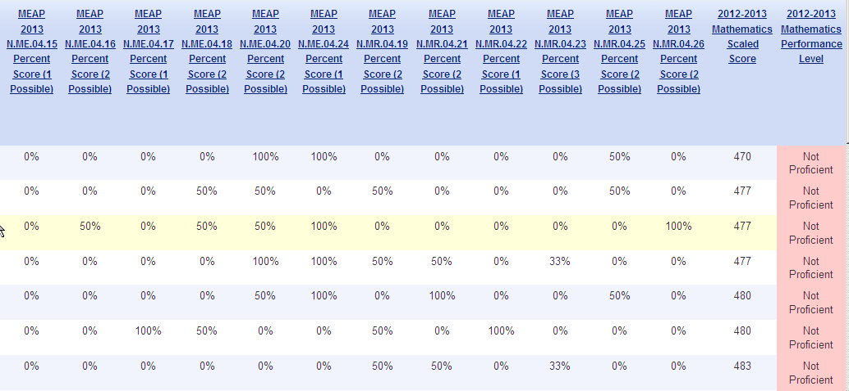
What you can get:

How to get it:
- Log into Data Director. Use your district website or www.cgresd.net
- Click on the student button in the bottom left corner:

- Select a year- 2013-2014 will get you current students, regardless of the year tested.
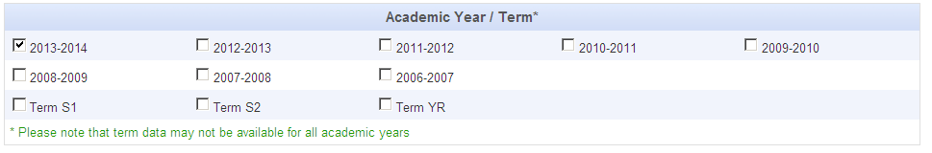

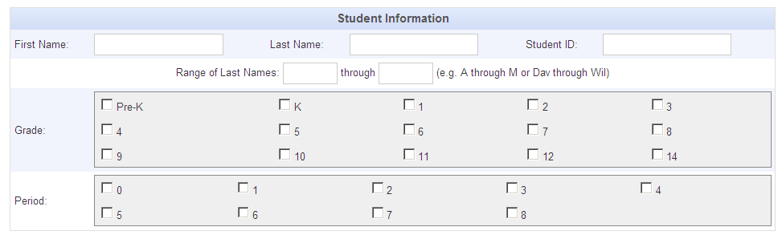
- Select the current grade that students are in. Teachers can select by period, administrators should not.

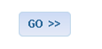
- Click Go!

- You will see a list of students, UICs, grades, and years.
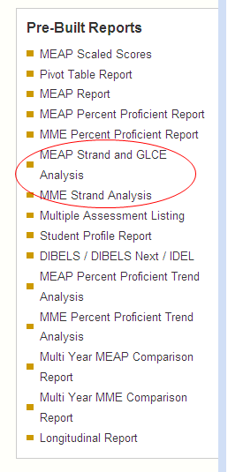
On the left hand side, scroll down and click on MEAP Strand and GLCE analysis OR MME Strand Analysis.

- Select a Subject
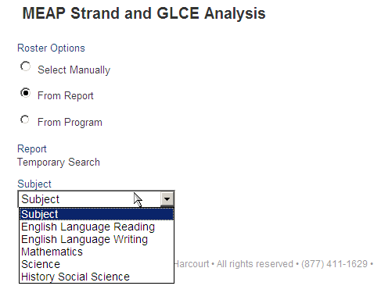

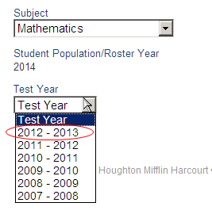
- Select a Test Year

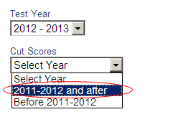
- Select the new cut scores:

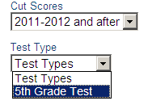
- Select the Test Type:

- To add specific Strands, select
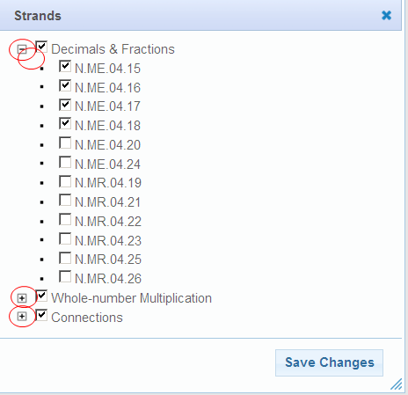
Then, use the + sign to open up strands to view.
Click Save Changes.

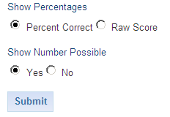
- Choose Percent correct or Raw score and Click Submit.

- Click on the Scaled Score to sort the list- the bottom 30% will then be at the top of the list!
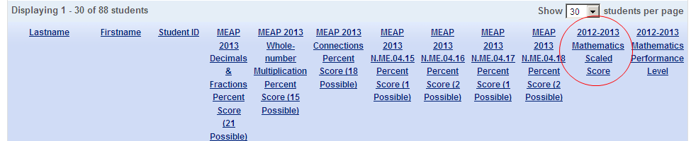

- To save this as a PDF or an Excel document select the icons below the name of the report.
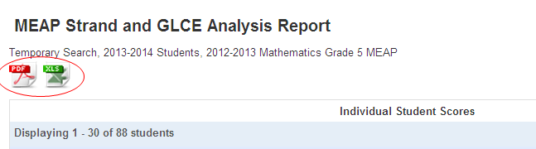

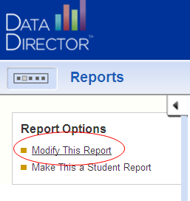
- To change the report, select Modify This Report at the upper left hand side. You can now change any of the options you had previously selected.

Questions, issues, concerns?
Call Joe Trommater
989-386-8602
jtrommater@cgresd.net

