Texas Reality Check Website-Printable
http://texasrealitycheck.com/
- This is the home screen. There is sound with this site as well as text. To get started click on the red arrow. (note: this site is specific to Texas, but can be used anywhere)
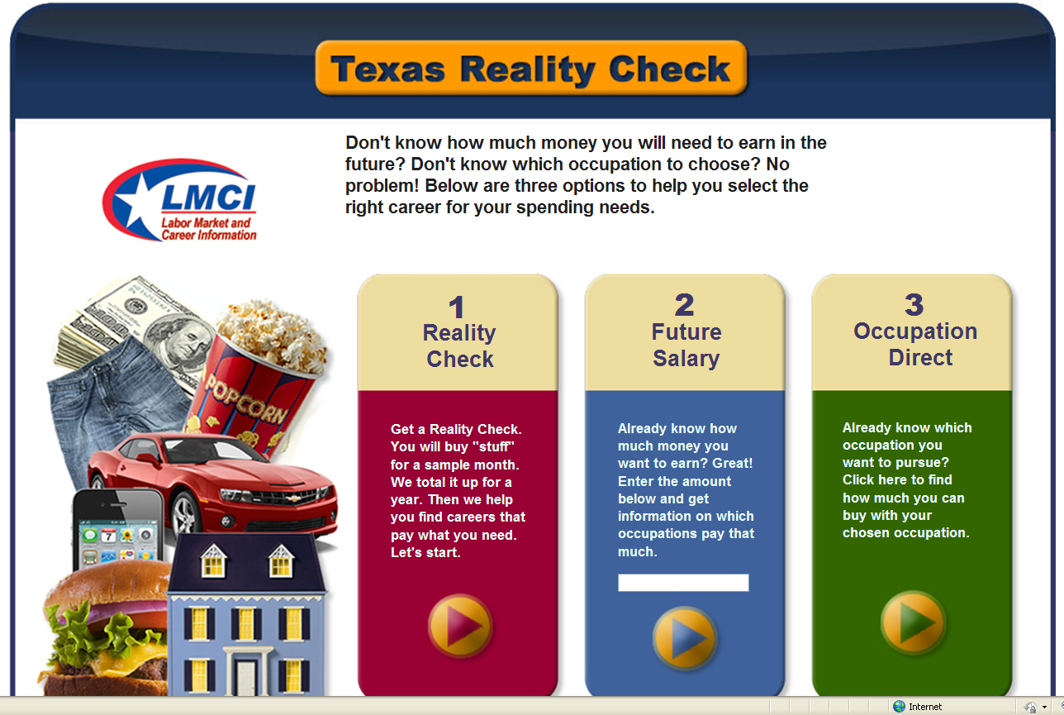

- You will see the “where do you want to live?” page. You get to choose a town/city in Texas by clicking on the name.

- Next, you get to choose the type of housing you want. If you hover over a housing type you will see a description and cost. Once you have selected your type of housing click next.

- Now for utilities. You can choose more than one. Click next to continue.
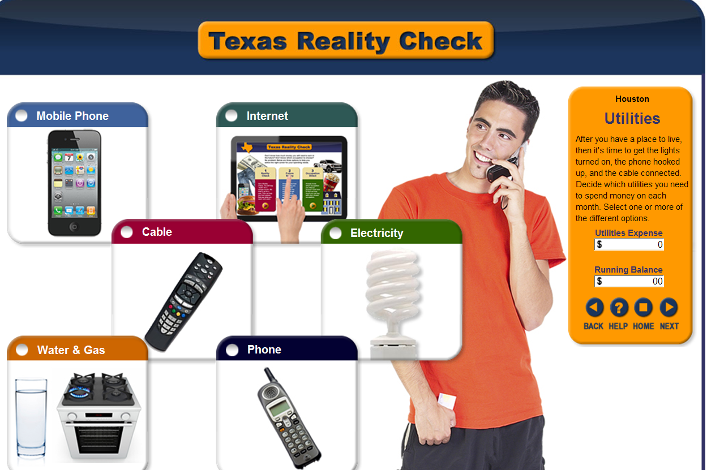

- Food is next. When finished click on next.

- You will continue through transportation, clothing, health care, personal items, entertainment, misc. savings, and student loans/debts. When finished there will be a total of all expenses. Now, continue on the “career”. This screen you will see what salary you will need to meet your expenses. You will need to select your education and occupation cluster. Now, click on “Find Careers”.

- Careers will be listed by your selections from the previous screen. You can go back if changes need to be made.
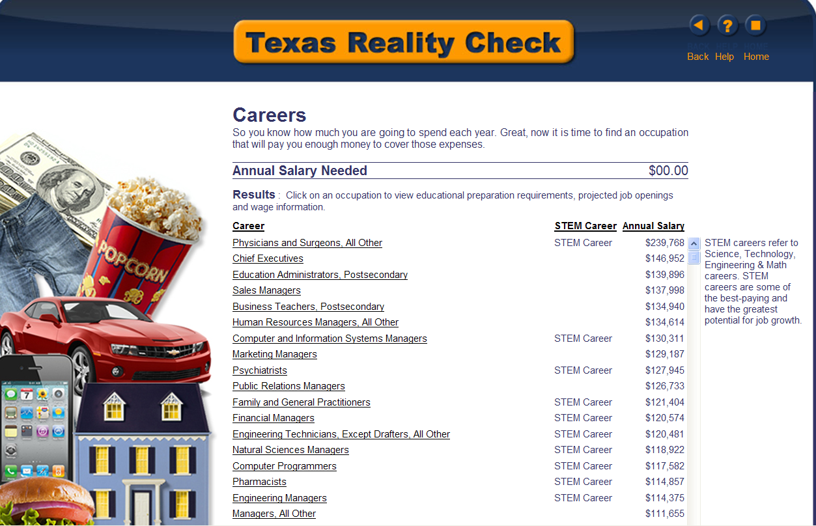

- If you want to know more about an occupation click on the occupation and you will be taken to a screen similar to this example.
