GCF Learn Free Website-Printable
http://www.gcflearnfree.org/
- Use the above link to access the GCF Learn Free website. This is what the site looks like.
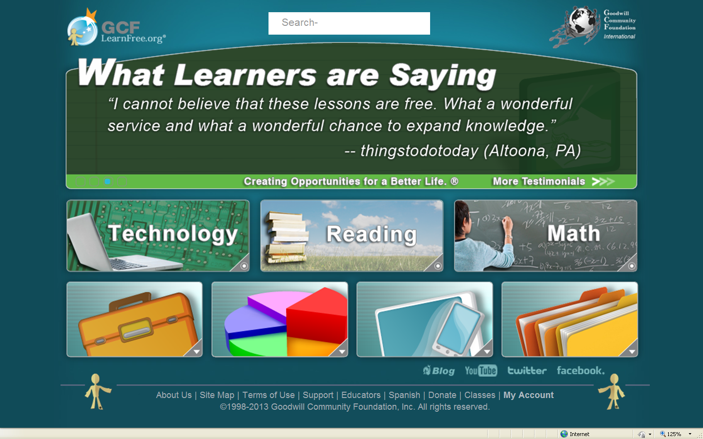

- When you click on a button the menu appears above.
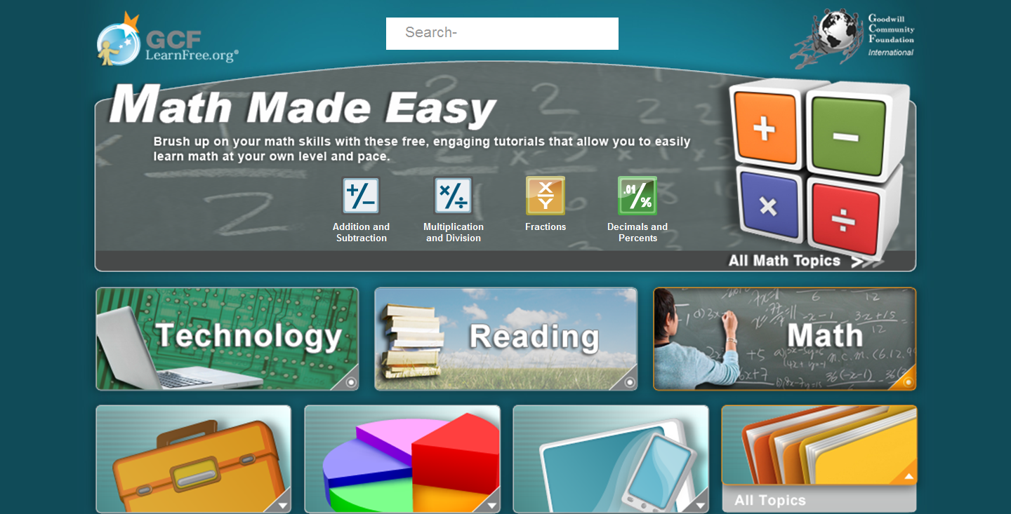

- Click on the “file box” for career and life skill areas. Click on the green $ to bring up the money skills page.
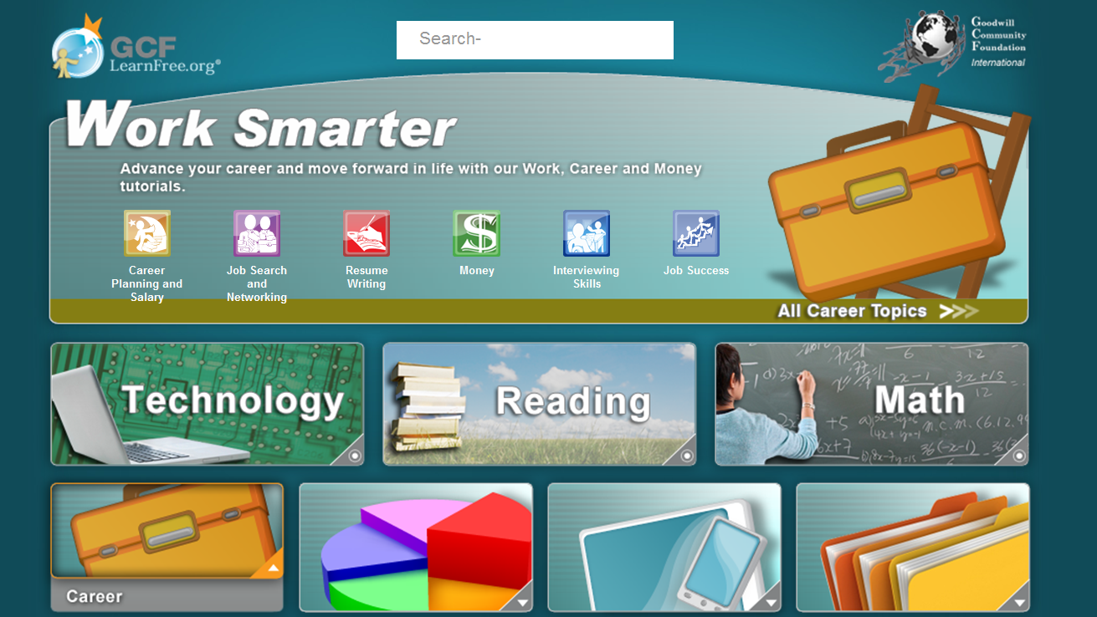

- In the video, we used the example of the “vending machine”. Click on “Vending Machine”
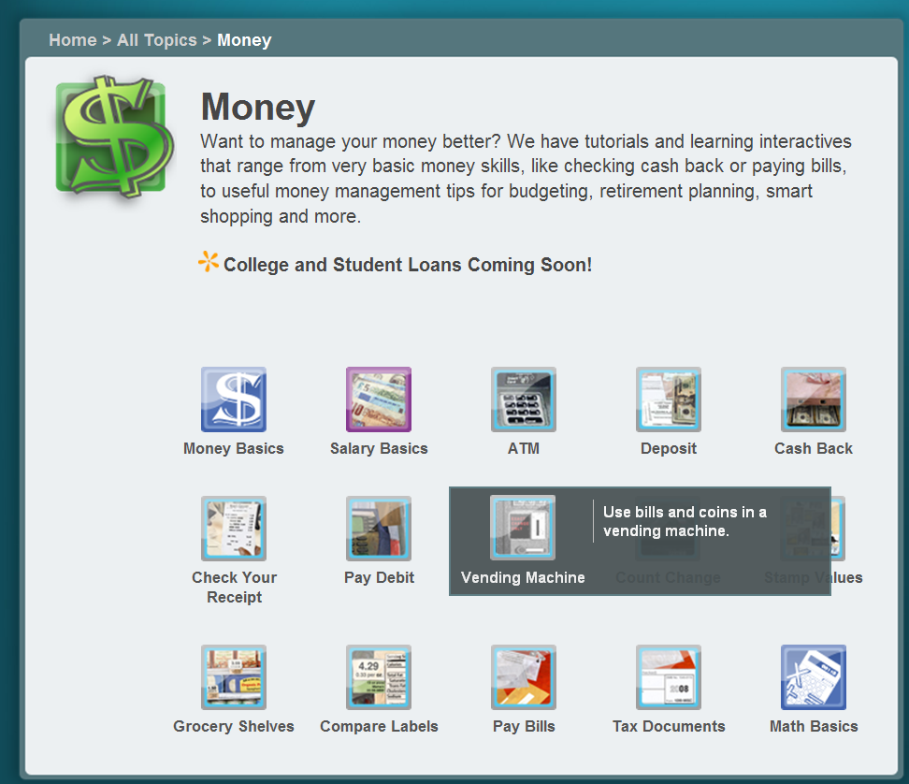

- The following page appears. You have the option of “Start Activity” or “Print” the activity.
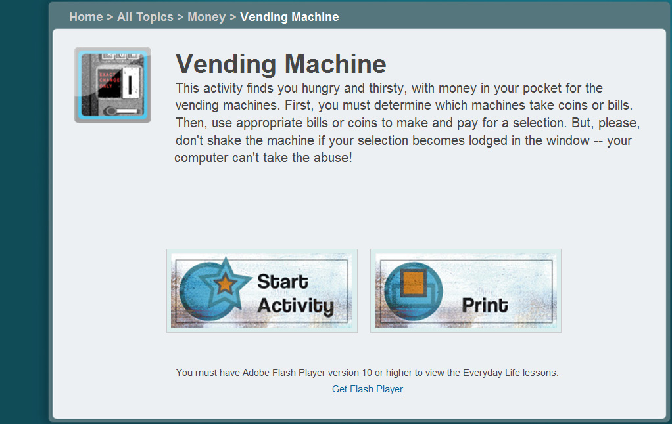

- If you select “Start Activity” you will see the following pages. Once you see the color page the sound begins and you can start making choices.
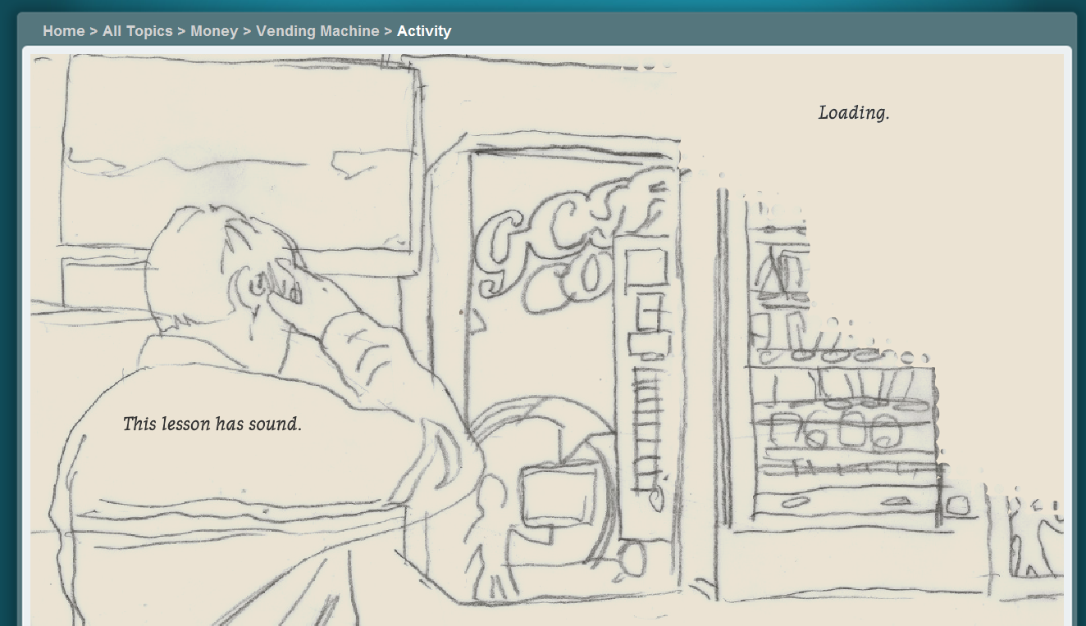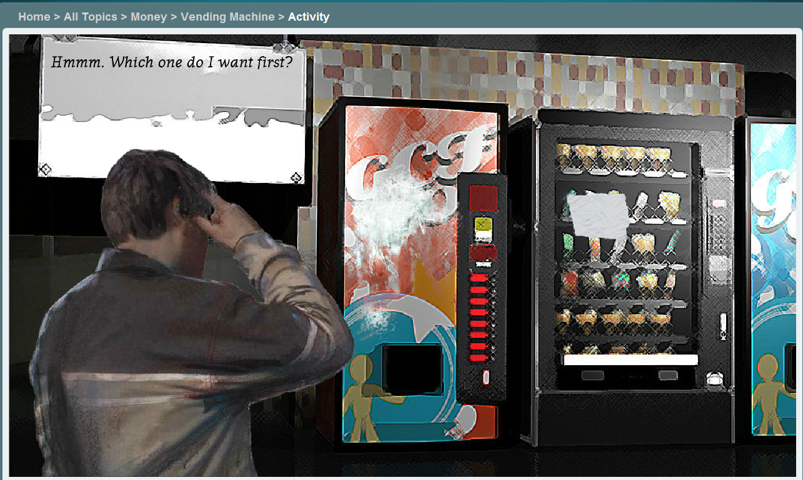

- Toward the top, you will see “breadcrumbs” to find your way back to “home” or to a previous page. If you go to “All Topics” you will be able view all of the areas offered on this site.
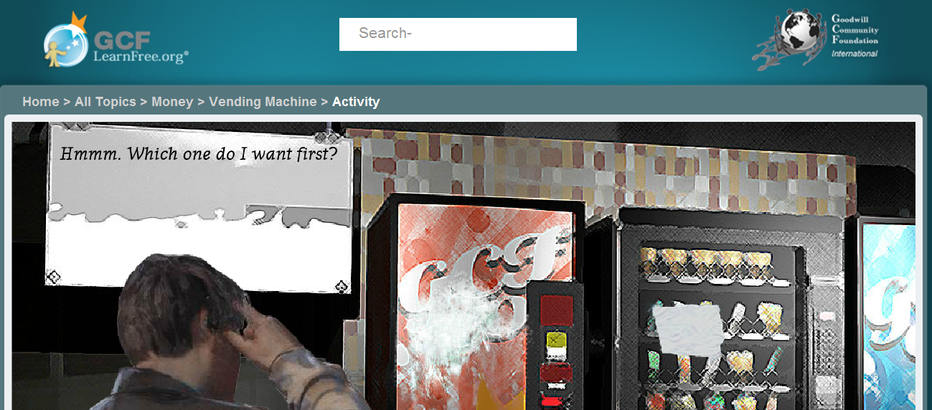

All Topics view (note: This is a partial view/list)
