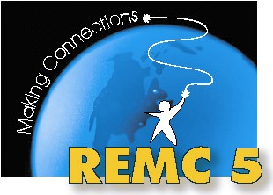REMC 5 Advisory
February 1, 2013
Winding Brook Conference Center – Shepherd

AGENDA

Morning – Professional Learning

9:00 – 12:00 Flipping Out the 21st Century Classroom

Presenters: Steve Kelly, St. Louis HS & Zach Cresswell, Mt. Pleasant HS

Afternoon – Business Meeting

http://tinyurl.com/remc5ac

- Welcome and Introductions

- REMC Statewide Projects
  - Connected Educator Series – New Episode (Digital Storytelling)
  - Blended Learning in the Classroom Course – February 5 at Winding Brook - flyer
  - MAISA Common Core Units Project
  - 21 Things for Students
  - MACUL/REMCAM Partnership
    - FREE MACUL Membership - flyer

- REMC Local Projects and Initiatives
  - REMC 5 Annual Report for 2011-2012 - handout
  - 22i Grant – Technology Readiness Professional Development Activity
  - Trainings:
    - 21 Things for Teachers (April/May – August) - flyer
    - 21 Things for Teachers – focus courses (tentative)
    - Online Assessment Options (April/May)
    - Moodle Bootcamp (June and August)
    - Best of MACUL (July) - flyer

- Student data
  - DataDirector vs. PowerSchool/Skyward

- Open sharing & discussion
  - Digital Learning Day – February 6th
  - MAME Region 5 funds – Mike Brodbeck

Next meeting: May 1, 2013 at Clare-Gladwin RESD

