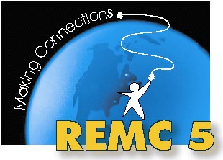
REMC 5 Advisory
October 29, 2012
Gratiot-Isabella RESD - Ithaca
AGENDA

Morning – Professional Learning

9:00 – 9:45 Edmodo
9:45 – 10:30 LiveBinders
10:30 – 10:45 Break
10:45 – 11:15 CAPspace
11:15 – 12:00 Online assessments with DataDirector
12:00 – 12:30 Lunch and Networking

Afternoon – Business Meeting

12:30 – 12:40 Welcome and Introductions

12:40 – 12:50 Moodle for our Advisory group
http://tinyurl.com/remc5ac

1:00 – 1:30 REMC Statewide Projects
- REMCAM Annual Report for 2011-2012
- Projects overview
- Michigan Digital Learning Conference – November 15 & 16 at Macomb ISD
- Michigan Moodle Moot – January 10, 2013 at Clinton County RESA

1:30 – 2:15 REMC Local Projects and Initiatives
- REMC 5 Draft Annual Report for 2012-2013
- Moodle
  - Upgrade to 2.3 coming in the spring
  - Training Nov. 2nd @ Winding Brook, Nov. 29th at CGRESD
- DE Streaming
  - Website updated over the summer
  - Adding Students
  - REMC 5 Day of Discovery October 17th – possibly a repeat in the spring
- Videoconferencing
  - CAPspace and TWICE
  - ASK Programs
  - Read Around the Planet
2:15 – 2:30 Open sharing & discussion

Next meeting: February 1 at Winding Brook
Professional Learning: Flipped Classroom with Steve Kelly and Zach Cresswell

