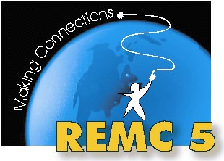
REMC 5
Technology Integration Advisory
Planning Meeting

May 18, 2012
Winding Brook Conference Centre

AGENDA

12:00 – 12:30 Lunch and Networking

12:30 – 12:45 Welcome and Introductions

12:45 – 1:00 What is REMC??
-Regional Educational Media/Technology Centers
-Statewide Association
-Our local REMC 5

1:00 – 1:30 REMC Statewide Projects

1:30 – 2:00 REMC Local Projects and Initiatives

2:00 – 2:30 Open discussion – future of this group
-Professional Learning Community
-Meetings/Professional Development
-Communication

