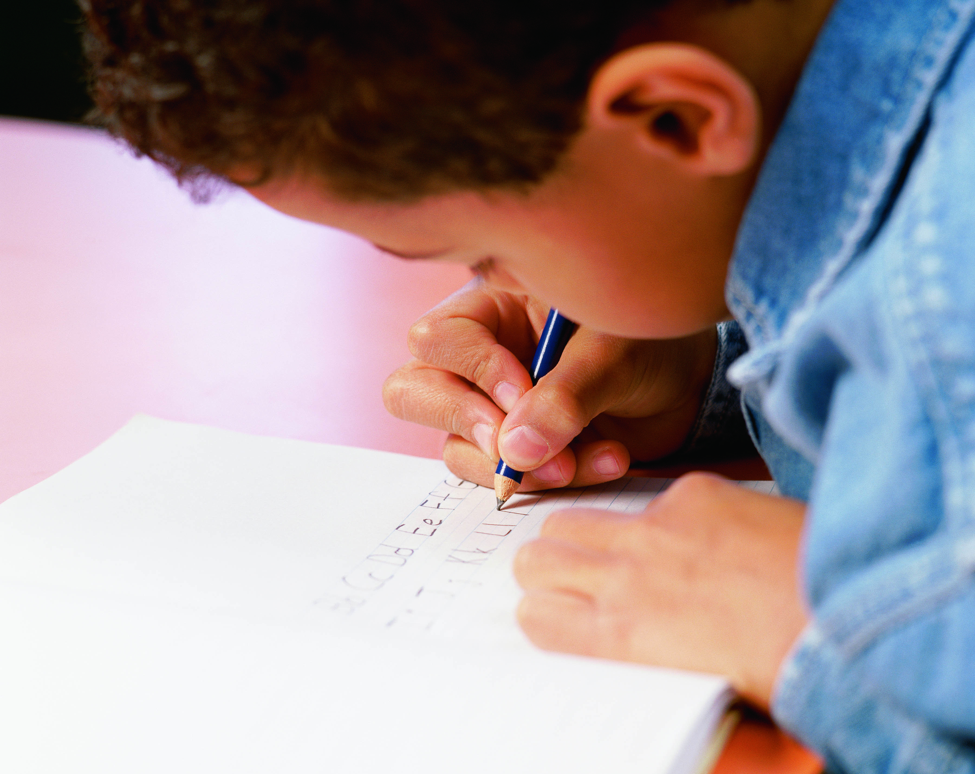
Writers Workshop Unit of Study
2nd Grade
Lifting the Level of Narrative
Writing through Studying Craft
Unit 2 - Resources
ELA
Common
Core
Standards

Writers Workshop Unit of Study
2nd Grade – Lifting the Level of Narrative Writing Through Studying Craft, Unit 2
Resources

Resource number refers to the Session in which it is first mentioned.

Session and Resource

Background Information Resource A – Possible Mentor Text x

Session 6 - Writing Process Steps x

Session 8 – Craft Chart of Noticings x

Session 10 – Possible Focus Lesson Format for Teaching a Crafting Technique x

Session 12 – Exclamation Points x

Session 13 – Simile Examples x

Session 21 – Student Self Reflection x

Misc. Resources

Calendar of Sessions x

Assessment Resources

See and Hear Writers – See individual lessons x

Class Profile Checklist based on Teaching and Learning Points x

Developmental Continuum for Narrative Writing – see www.readingandwritingproject.com x

Checkbric (under construction) x

Conferring Focus Areas (under construction) x
Unit 2 Background Information Resource A

Possible Mentor Texts –
Lifting the Level of Narrative Through Studying Craft

Literature – Trade Book Suggestions
Author | Title | Notes to Teacher
Jonathon London  (core author for unit) | Dream Weaver  Puddles  Hurricane!  When the Fireflies Came  Old Salt, New Salt  Froggy Gets Dressed  Tell Me a Story  Other books of interest to students | Main character is an animal, but 2nd grades love the craft  Biography about author’s life and writing habits
Cynthia Rylant | The Great Gracie Chase Stop That Dog!  The Relatives Came  Other books of interest to students | Feature book to show can learn craft from other authors too
Mem Fox | Night Noises  A Bedtime Story  Other books of interest to students
Rachel Isadora | Max  Ben’s Trumpet  Other books of interest to students
Eve Bunting | Smoky Night  The Memory String  Other books of interest to students
Angela Johnson | -Check if 1st grade used her as a feature author, if not great author to study  -See Authors as Mentors by Calkins
Donald Crews | Shortcut  Night at the Fair  Check if 1st grade used him as a feature author, if not great author to study
Julie Brinkloe | Fireflies | Feature book to show can learn craft from other authors too
Maribeth Boelts | Those Shoes
Karen Ackerman | Song and Dance Man
Charlotte Zolotow | The Old Dog
Marla Frazee | Roller Coaster
Darleen Bailey Beard | Twister

Student Authored Work Code: SW
Author | Topic/Title | Notes to Teacher
Lucy Calkins | Authors as Mentors book | Many good examples of student work included

Teacher Authored Work Code: TW
Author | Topic/Title | Notes to Teacher

Common Core Code: CC
Author | Topic/Title | Notes to Teacher
Second Grader | My First Tooth is Gone

Teachers College (www.readingandwritingproject.com) Code: TC
Author | Topic/Title | Notes to Teacher
Alexandra Giles | Help!
Chloe | Dazter!
Julian | The First Day

Websites Code: WWW

Unit 1 Resource: Session 2B/ Unit 2 Resource: Session 6

Unit 2 Resource: Session 8

CRAFT CHART OF NOTICINGS

Book: ____________________________________________ Author: ________________________________________

Notice Why? Name It Connections Try It

Unit 2 Resource: Session 10

POSSIBLE FOCUS LESSON FORMAT FOR TEACHING A CRAFTING TECHNIQUE

1. SHOW Show an example of a crafting technique.
2. EXPLAIN Explain why the writer might have chosen to craft in this way.
3. NAME Give the craft a name.
4. CONNECT Show other examples of the crafting techniques in other texts. (books, poems, student or teacher projects, etc.)

5. ENVISION Envision this crafting technique by thinking aloud how it might
work in student writing. Also, called Write-in-the-Air.
6. INFORM “If anyone tries this, be sure to let me know.”
* * * *
TRY IT At times have students try the crafting technique with a sample text.

RECORD Students may write an example/explanation of the crafting technique in their notebooks.

Adapted from: Ray, Katie Wood. 1999. Wondrous Words: Writers and writing in the elementary classroom. Urbana: NCTE.

Unit 2 Resource: Session 12 – Exclamation Points

Book: Shortcut by, Donald Crews
Page Number | Excerpt from text
12 | - “I HEAR A TRAIN!”
15 | - “Back to the cut-off!”
16 | - “THE TRAIN! THE TRAIN!”  “GET OFF! GET OFF!”  “GET OFF THE TRACKS!”

Book: Fireflies by, Julie Brinckloe
Page Number | Excerpt from text
7 | - Fireflies!
13 | - “Fireflies!”
14 | - Fireflies!
15 | - “Catch them, catch them!” we cried grasping at the lights.
16 | - “I caught one!”
17 | - “I can catch hundreds!”
29 | - “Fly!”
31 | - Fireflies!

Book: Song and Dance Man by, Karen Ackerman
Page Number | Excerpt from text
6 | - “Supper in an hour!” Grandma calls from the kitchen.
13 | - “Yay, Grandpa!”
16 | - He says, “Watch this!” and does a new step that sounds like a woodpecker tapping on a tree.
19 | - “One scoop of ice cream, two squirts of soda, and three scoops of elephant!”
21 | - “Drink slow and hold your breath,” he says, “or I’ll have to scare you!”
26 | - “Hurray!” and “More!” but Grandpa only smiles and shakes his head, all out of breath.

Unit 2 Resource: Session 12 – Exclamation Points

Book: Those Shoes by, Maribeth Boelts
Page Number | Excerpt from text
17 | - “How exciting! Grandma says.
25 | - “I’m not going to do it!” I say.
Book: Puddles by, Jonathan London
Page Number | Excerpt from text
4 | - Ka-BOOM!
7 | - “Watch out for puddles!” Mama hollers. “Don’t get wet!”
8 | - Look – the sparkle of a million suns in a million drops!
13 | - Puddles! Big ones, little ones,  long ones, skinny ones –  pieces of sky  on the ground.  It’s time to puddle-jump!  Splash splash splash!
20 | - At the pond, it’s time for the frogs  to play! And we want to play  with them. Leap frog, leap!  Leap frog, leap!  Hop, flop – plop!
22 | - Birds flap  From the trees  And we think the trees  Are applauding!  We bow, then say. “Bye frogs!”  And turn toward home.
25 | - Puddles! Big ones, little ones,  long ones, skinny ones –  pieces of sky  on the ground.  It’s time to puddle-jump again!  We can hit every puddle  from the pond to the meadow -  splash splash splash!
28 | - “We’re home!”  “You’re wet!’ Mama howls.
32 | - to puddle-jump – splash splash splash!

Unit 2 Resource: Session 12 – Exclamation Points

Book: The Great Gracie Chase Stop that Dog! by, Cynthia Rylant
Page Number | Excerpt from text
6 | - So, when they arrived one day to paint Gracie’s kitchen, she did not like it! Here they came in a big, noisy truck!
9 | - There they were at the door with their clangy ladders and big-person voices!  There they were dragging chairs across Gracie’s quiet kitchen floor!
11 | - Gracie was put outside!
13 | - And she did not like it one bit!  - Gracie decided to take a walk – ALL BY HERSELF!  - Gracie was supposed to be a good dog and never go through that gate by herself. But she did!
15 | - “THERE’S GRACIE!” Gracie started to run!
16 | - Gracie did not know why she was running except that suddenly everybody in the world was trying to catch her! And she did not want to be caught!
22 | - The chase got bigger. “Stop that dog!” everybody cried, which only made Gracie run faster. And soon the whole town was watching (or running in) the Great Gracie Chase!
25 | - But she couldn’t stop running now!  Everyone wanted to catch her!
27 | - And one by one by one, all the people had to stop BECAUSE THEY COULD NOT KEEP UP WITH GRACIE!
31 | - So that silly little dog turned around and walked back home ALL BY HERSELF!
32 | - That silly little dog!

Unit 2 Resource: Session 13 – Simile Examples

Book: Dream Weaver by Jonathon London
Page Number | Excerpt from text
7 | A sudden wind, and the trees hum, the branches creek, and yellow spider’s web shimmers, like wind across a pond.
22 | Yellow spider glows like the evening star, gleaming over the sea beside the crescent moon.
26 | In your window the evening star hangs like yellow spider on her invisible web.

Book: Fireflies by Julie Brinckloe
Page Number | Excerpt from text
17 | The jar glowed like moonlight and I held it in my hands.
18-19 | Then we dashed about,  waving our hands in the air like nets,  catching two, ten-hundreds of fireflies,  thrusting them into jars,  waving our hands for more.
24 | They blinked off and on, and the jar glowed like moonlight.
26 | The light in the jar turned yellow, like a flashlight left on too long.
27 | And the light grew dimmer,  green,  like moonlight under water.
31 | Blinking on, blink off,  dipping low, soaring high about my head,  making circles around the moon,  like stars dancing.

Book: Old Salt, Young Salt by Jonathan London
Page Number | Excerpt from text
10 | It was as big as a school bus.
14 | It sounded like the drone of the motor.
21 | The fish was as long as my arm.
23 | He pointed toward the tall cliffs, which looked as thin as a pencil in the distance.

Book: Puddles by Jonathon London
Page Number | Excerpt from text
6 | In the morning it does---like a curtain rising on a shiny new day, a day of brightness and blue.
16 | We kneel and watch worms squirm and stretch and leave tiny trails in the muck like sloppy writing—they’re learning the ABCs of weather, of rain and sun and mud.

Unit 2 Resource: Session 13 – Simile Examples

Book: Song and Dance Man by Karen Ackerman
Page Number | Excerpt from text
12 | He tucks small, white pads inside the shoes so his corns won’t ‘rub, and he turns on the lamps and aims each one down like a spotlight.
14 | His feet move slowly at first, while his tap shoes make soft, slippery sounds like rain on a tin roof.
16 | He says, “Watch this!” and does a new step that sounds like a woodpecker tapping on a tree.

Book: Twister by Darleen Bailey Beard
Page Number | Excerpt from text
 | Out we run, like the little rabbit.
9 | Far away, the sky looks green, like Mama’s guacamole.
30 | Hailstones sparkle like glittering diamonds and crunch under our shoes.

Unit 2 Resource: Session 21

Name ______________________________________________ Date ____________________

Student Reflection On Craft

What are you most proud of in this unit?

Which crafting techniques did you like best?

What did you learn about Reading Like a Writer and craft?

Did you like this unit of study? Why or why not?

Name some goals for you as a writer that you will try in the next unit of study.

Based on Stephanie Parsons (2007). Second Grade Writers. Portsmouth, NH: Heinemann
Assessment - 2nd Grade Unit 2: Lifting the Level of Narrative Writing Through Studying Craft DRAFT

Student Names | Writers explore a mentor text looking for interesting decisions an author made. | Writers are people, exploring an author’s personal life and background. | Writers are people, exploring an author’s personal life and background. | Writers intentionally make choices when they write. | Writers live a “writerly” type of life: Tiny Topic Notepads. | Writers select a tiny topic and rehearse their story ideas. | Writers sketch and write a discovery draft. | Writers study the work of a mentor to see HOW the author made his or her story. (developing a craft chart) | Writers study the work of a mentor to see HOW the author made his or her story. ( writing-in-the-air ) | Writers use a storyteller’s voice through dialogue to bring a moment alive. | Writers find writing mentors in all authors. | Writers study a crafting technique to try in their own writing. - Focus on punctuation. | Writers study a crafting technique to try in their own writing. - Focus on similes or other crafting technique. | Writers vary sentence structure to bring style to their writing. | Writers work with partners to add finishing touches to their final pieces. | Writers edit so readers can read their texts smoothly. | Writers edit so readers can read their texts smoothly.
Assessment - 2nd Grade Unit 2: Lifting the Level of Narrative Writing Through Studying Craft DRAFT

Student Names | Writers edit so readers can read their texts smoothly. | Writers work on putting finishing touches on their books and creating “About the Author” blurbs. | Writers share with an audience.

2nd Grade Lifting the Level of Narrative Writing through Craft: Sample Writing Unit of Study

Week 1 | Date:  S1: Writers explore a mentor text looking for interesting decisions an author made. | Date:  S2: Writers are people – exploring an author’s personal life and background. | Date:  S3: Writers are people – exploring an author’s personal life and background. | Date:  S4: Writers intentionally make choices when they write. | Date:  S5: Writers live a “writerly” type of life: Tiny Topic Notepads
Week 2 | Date:  S6: Writers select a tiny topic and rehearse their story ideas. | Date:  S7: Writers sketch and write a discovery draft. | Date:  S8: Writers study the work of a mentor to see HOW the author made his or her story into a wonderful one – Focus on developing a craft chart. | Date:  S9: Writers study the work of a mentor to see HOW the author made his or her story into a wonderful one – Focus on writing-in-the-air and trying it! | Date:  S10: Writers use a storyteller’s voice through dialogue to bring a moment alive.
Week 3 | Date:  S11: Writers find writing mentors in all authors. | Date:  S12: Writers find writing mentors in all authors. | Date:  S13: Writers study a crafting technique to try in their own writing. (Focus on punctuation) | Date:  S14: Writers vary sentence structure to bring style to their writing. | Date:  S15: Writers study a crafting technique to try in their own writing. (Focus on similes)
Week 4 | Date:  S16: Writers vary sentence structure to bring style to their writing. | Date:  S17: Writers work with partners to add finishing touches to final piece. | Date:  S18: Writers edit so readers can read their texts smoothly. | Date:  S19: Writers edit so readers can read their texts smoothly. | Date:  S20: Writers edit so readers can read their texts smoothly.
Week 5 | Date:  S21: Writers work on putting the finishing touches on their books and creating “About the Author” blurbs. | Date:  S22: Writers celebrate by sharing their published picture books with an audience. | Date:  S23: UNIT WRAP UP: Student Reflections and Clean out folders | Date: | Date:

