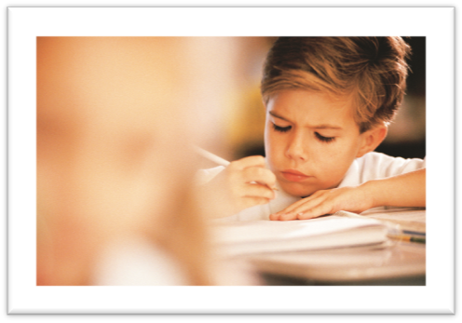

ELA Common Core Standards

Small Moments:
Personal Narrative Writing
1st Grade
Unit 2 Resources

My Small Moment Ideas...
Resource 1
/////
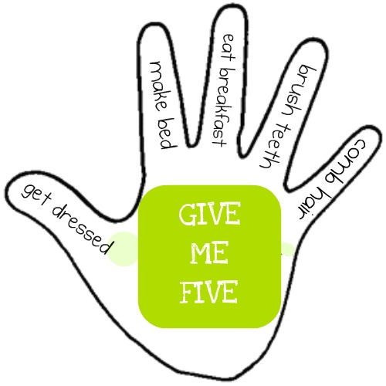



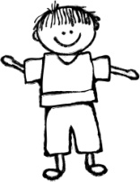




My Story Planning Organizer
Resource 2

Name _________________________________ Date ___________________________________

My Small Moments Reflection

After learning about Small Moments I now know…
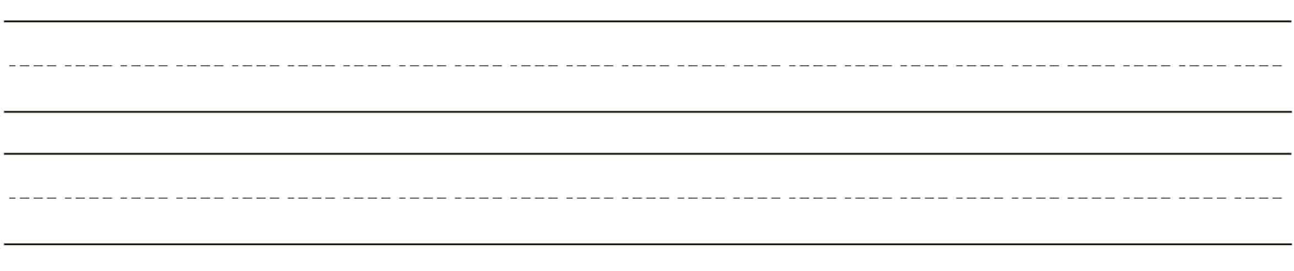

In my story I tried…
I became a stronger writer by…

Resource 3

Small Moments: Personal Narrative Writing –1st
Scoring Sheet

4 - Exceeding Proficiency (above) All Proficient AND 3 of the 4 Exceeding Targets
- Includes speech bubbles and/or dialogue to show characters talking
- Adds more details to their stories to write a story with a beginning, middle, middle, end (4-5 page booklet)
- 3 or more sentences per page
- Easily readable by teacher
3 - Proficient (at) must have ALL 6 of the AT Targets
- Writes a focused small moment with a beginning, middle, and end (3 page booklet)
- 2-3 sentences per page
- Includes a setting
- Writes an ending that is “close in” to the moment
- Uses ending punctuation (.!?)
- Shows evidence of at least one change to make their piece more readable (ex: change in spelling, additional punctuation, capitalization, adding missing words…)
2 - Approaching Proficiency (approaching)
- Meets 4 to 5 of the “at” targets
1 - Not Yet Proficient (below)
- Meets 3 or less of the 6 “at” targets

Resource 4
Name ______________________________________________________ Date ___________________________________________________
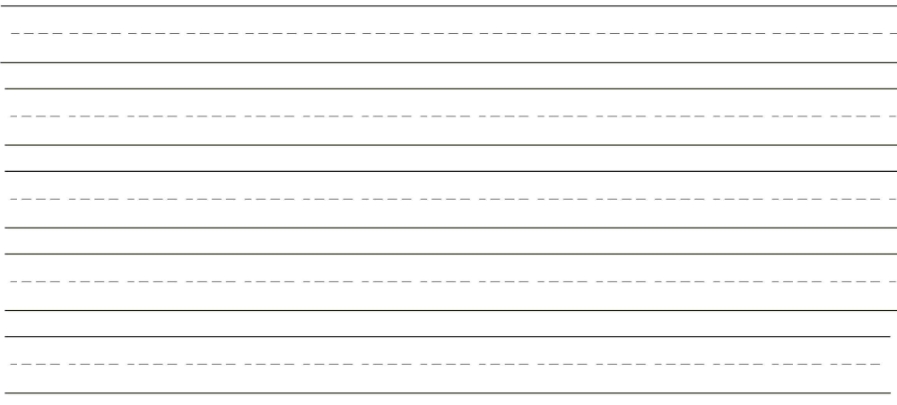
Who
Where
What

Name__________________________________________ Date___________________________________

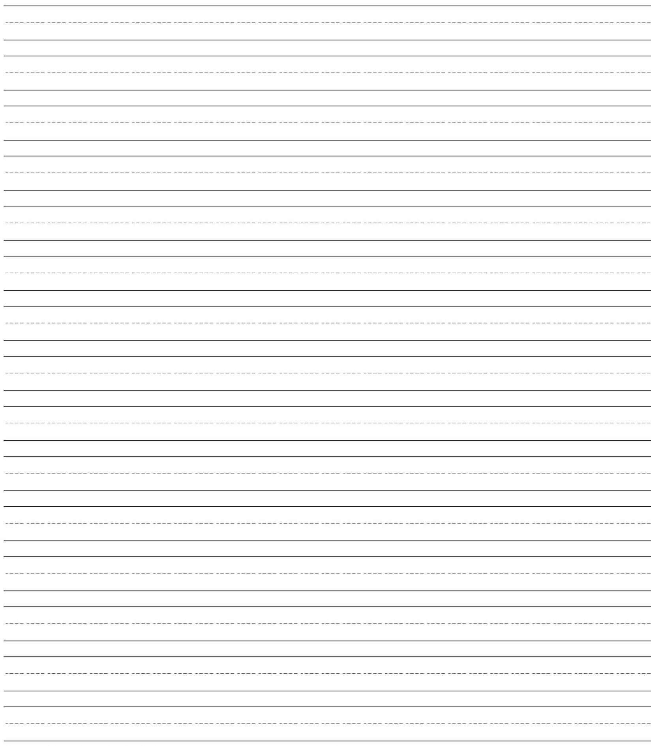

Name__________________________________________ Date___________________________________
2

3

4

5

