New BAA Secure Site quick reference guide for administrators.

Since the release of the new BAA secure site, all access to the site was re-set. That means that by default, no one has access to your district data, not even the superintendent. This guide will help you grant appropriate access to the people in your district who need it.

**Step One** Request access for District Administrator(s) (many schools have done this already)

Superintendent: Sign the District Administrator User ID Request found here: <https://baa.state.mi.us/BAASecure/pdfs/BAASecureSiteDistrict.pdf>

This should be filled out for each person who you want to be able to grant access to district data. You may wish to select more than one person for this role so that more than one person in the district can grant access. To become a District Administrator yourself, you will need to fill out both columns of this form. This form needs to be faxed to the number shown on the form.

Once access has been granted, the District Administrator can log into the secure site using their MEIS login and password.

**Step Two:** Granting access to other users.

Other users can request access by going to <http://www.michigan.gov/mde>. 

Click Here!

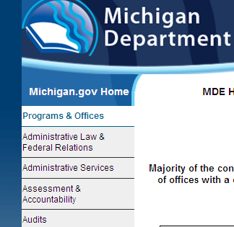

Then Here!

And Finally Here!

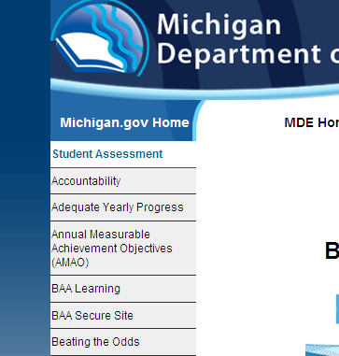



**Step Two:** Granting access to other users. (contd.)

Log in using your MEIS ID and Password. This is different from the old website!

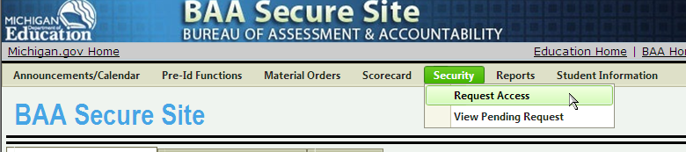You can request access using the Security tab. If you do not yet have access, the Security tab is the only one present.



You may also see only a button like this:

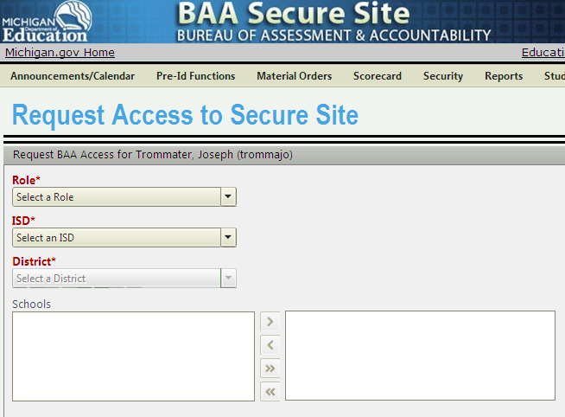Now you are at the Request Access Screen. Select a role bring up the options on the right.

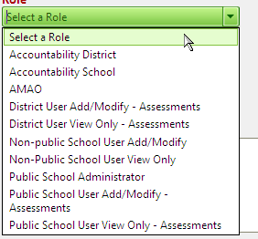

Public School Administrator will be the most likely choice for principals and MEAP Coordinators.

Select the appropriate ISD and District.



**Step Two:** Granting access to other users. (contd.)

Once a district is chosen, schools will appear. Select a school on the left, and click on the arrow shown to move them to the right.

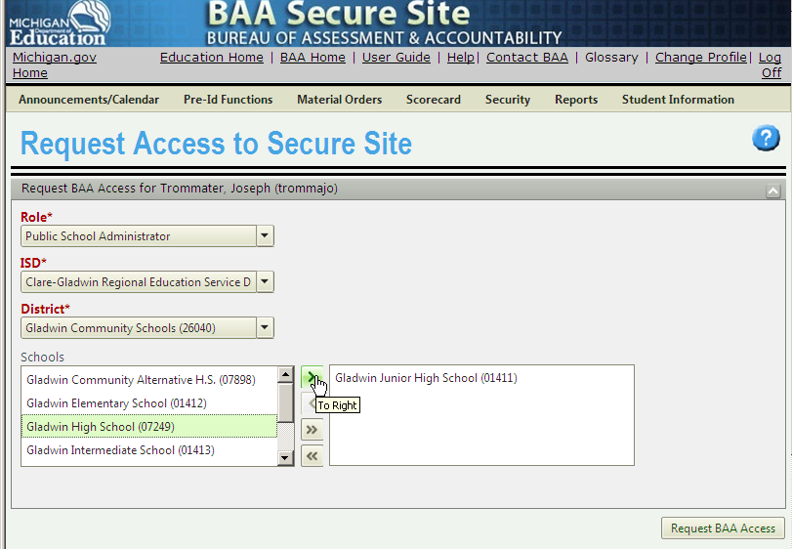

Click here to request access for the schools shown.

Schools you are requesting access for

You should get a BAA Security Request Notification.



**Step Three** Granting requests.

All district administrators will receive an email from [baa@michigan.gov](mailto:baa@michigan.gov) telling them that a request for access has been made. This email goes to the address listed in their MEIS Account, so this email may never come if their MEIS Profile is not up-to-date!

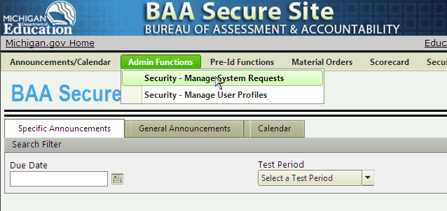Once the District Administrator logs in as outlined above, they can view access requests through the Admin Functions tab.

You will see…nothing. You must click search to see a list of access requests!

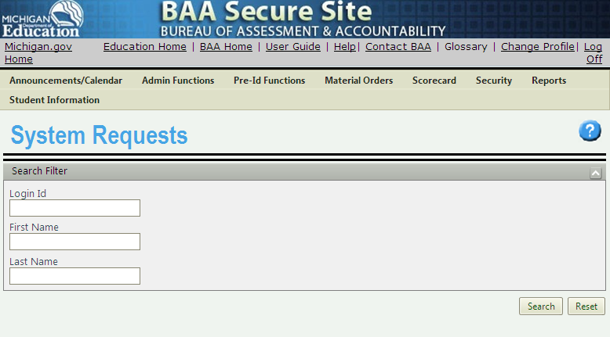

Click here to see requests!!!



**Step Three** Granting requests. (contd.)

Requests are now visible.

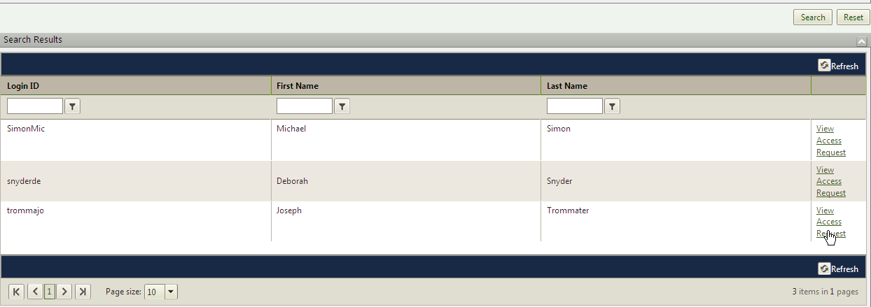

Click View Access Request to see what kind of access has been requested.

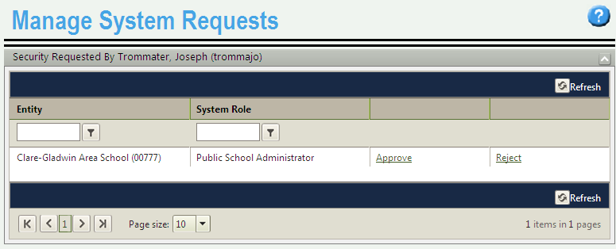

You can Reject access with an explanation, or Approve and select the type of access to grant (you can grant access that was not requested).



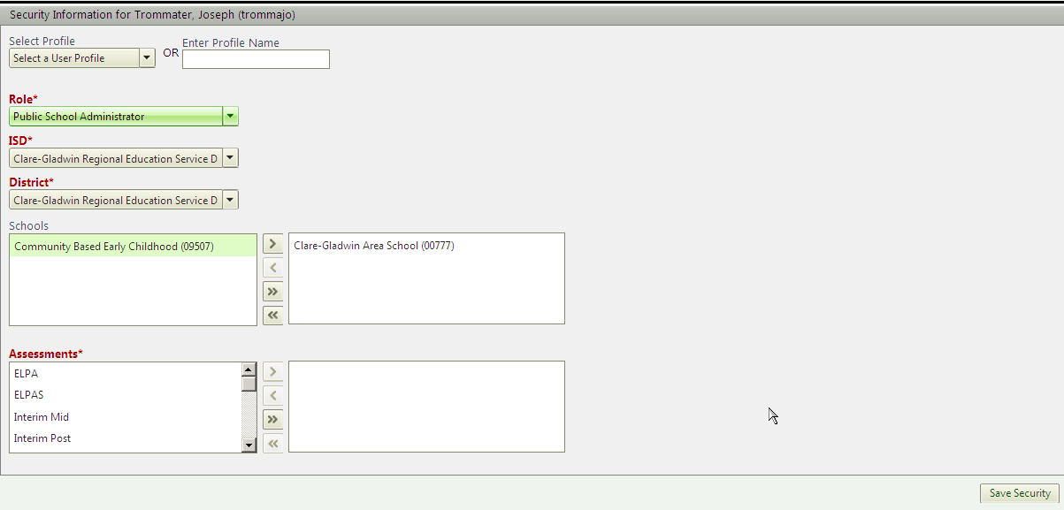You will see a screen similar to the one above, and can grant access to individual schools and assessments.

You can change the Role if you feel it is inappropriate.e.

You can grant access to more or fewer schools within the district. By selecting them and using the left arrow.

You can give access to all assessments using the double arrow, or pick and choose using the single arrow.

Click Save Security to grant access. The user will receive an email confirmation to the email account in MEIS. 

Once access has been granted, it can be changed at any time by the District Administrator.

If you need information on specific topics, here is the 275 page user guide for the BAA Secure Site:

<https://baa.state.mi.us/BAASecure/pdfs/SecureSiteUserManual.pdf>

It is long, but goes over many of the common things that need to be done in the secure site.

